
December 7, 2012
Van Lynch,
Senior Planner
Carlsbad Planning Department
1635 Faraday Avenue
Carlsbad, CA 92008
Subject: Comments on DEIR
Quarry Creek Master Plan
Dear Mr. Lynch:

These comments on the Draft EIR are made on behalf of Preserve Calavera. Preserve Calavera is a grassroots organization whose mission is to preserve, protect and enhance the natural resources of coastal north San Diego County.

This project is the eastern half of the Buena Vista Creek Valley. Our organization has been concerned about a series of impacts to this valley over the last 12 years. During that time we have had numerous meetings with the developer in an effort to try to reduce these impacts. This is the last chance for all of us to do this right- design a development that leaves the priceless natural, cultural and historic resources of this valley intact. Unfortunately this developer has not risen to this challenge. We are hopeful that city staff and the Mayor and City Council of Carlsbad will use the broad discretion they have to reduce the significant adverse impacts of this project. Fortunately there are several alternatives to the proposed project that have been evaluated in this DEIR that will go a long ways toward addressing these community concerns. However, this DEIR, as presented has failed to identify numerous direct and indirect impacts or to provide adequate mitigation. A revised DEIR is required to satisfy both the legal requirements, and the community concerns about this project.

Our primary concerns with the project and the associated DEIR include the following:

- Loss of sensitive habitat in one of the primary core areas of the city

- Impacts on the local and regional wildlife movement corridors

- Loss of the historic, cultural sense of place

- Impacts of excessive development on the adjacent open space and community.

Preserve Calavera is a grassroots community based conservation organization. Many of our members who contributed to the preparation of this comment letter have developed considerable
skills and experience through their volunteer community work. This layperson perspective has been expanded and clarified through additional technical and legal input provided on our behalf by Everett Delano, Vonn Marie May and SWAPE in a separate comment letter.

5020 Nighthawk Way – Oceanside, CA 92056
www.preservecalavera.org

And of course many of the concerns that we have raised have been repeated in numerous comment letters you will be receiving from organizations and individuals throughout this region. This is a project with far reaching consequences in a valley many of us consider priceless. We hope that at the end of this process the interests of all of these community stakeholders have been addressed.

The following are our specific comments on the DEIR:

Project Description

-3-1 The off-site trail heads on Marron and Simsbury Courts will both cause indirect impacts that have not been identified, analyzed of mitigated. The experience of trail use in Carlsbad is that lots of people drive to the trail heads to walk and bike the trail. Our surveys of Calavera users on the trail by the Lake Calavera Dam found that about half of the trail users were not even residents of Carlsbad. In an area like this with such a significant regional draw- a sacred waterfall- it should be expected that many persons will be driving to these trail heads and that there will be a high volume of pedestrian, bicycle and dog use. This is of particular concern for the Marron trail head where the access will require walking through the BVCER- a state reserve that has not yet been opened to the public, does not have designated trails, and has no enforcement in place for things like keeping dogs on leash. Indirect trail impacts include noise, nest predation by pets, trash and litter, and nest disturbance nest disturbance.

3-2 The boundary of the Marron-Hayes Historic District does not coincide with the boundary of the privately owned parcel where the adobe is located- it is significantly larger. The DEIR incorrectly characterizes this area, both here in the project description and in the analysis of impacts to the historic resources. Please add a figure that shows the limits of the designated Historic District (see att) in relationship to the property boundaries and correct the analysis to reflect the actual boundaries of this historic resource.

-Figure 3 shows ownership of the Master Plan land as Hanson Aggregates. We found no explanation for why this project is being proposed by someone who is not being shown as the landowner. Of course it is widely known that McMillin will be acquiring this land once the mining reclamation is complete. The DEIR should identify this ownership change and explain how it impacts this project. Failure to do so is a significant inaccuracy in the EIR.

-Table 3-1 shows the basin at P-4 (and perhaps others since it is describes as “basins”) as part of the Public Use Area. In the DEIR section on Public Services the basins are also included as part of the active recreation land acreage. We do not recall any other EIR where storm water control measures like this are classified as public use/active recreation areas. Please provide further explanation of this including assumptions about depth and duration of water in these basins, type of plant cover and exactly what active recreation will be allowed in this area immediately adjacent to hardline open space that is designed for storm water control.

-3-10 description of allowed uses is not consistent with the provisions of the City of Oceanside Draft Sub-Area Plan (SAP) - for planning buffers, or the action of the City of Oceanside Planning Commission to add a 50’ planning buffer to the 100’ biological buffer around all wetlands. The city of Oceanside SAP should be the reference source for this requirement and the DEIR should discuss consistency (or in this case the lack of consistency) with this document. Please clarify what source was used to determine the allowed uses, identify where these are in conflict with the city of Oceanside provisions (it was Oceanside who imposed these as part of the adoption of the Amended Reclamation Plan), and provide further explanation that supports why the wrong guidelines are being used. Many of these stated allowed uses are in fact not allowed. This conflict is a significant land use and biological resources impact that has not been identified or mitigated. This 50’ planning buffer was required by the city of Oceanside because of concerns about protecting the biological resources with an anticipated high use public trail through this area.

-It is our understanding that the new Park and Ride Lot will replace the existing one further east on Haymar. Please clarify if that is the case. If so there are additional indirect impacts of relocating and expanding the Park and Ride lot that have not been identified or mitigated. How many people using the lot are expected to come from the adjacent development and will they be driving or walking to it? Other users of the lot will be accessing it from College- adding to the College traffic. How was this accounted for in the traffic study?

-The P-2 description includes a long list of potential community uses on this site. Please clarify how the decision will be made about the particular use, who will develop that site, timing of such development, and what condition the land will be left in until this occurs. Furthermore the potential uses could have very different impacts. A day care center generates significant peak hour trips. A community garden may have concerns about water use and run-off. A dog park could have issues of noise and odor. Please explain how the impacts of this site have been assessed in this DEIR when the actual land use is not specified.

-Figure 3-7 shows no trail connection through OS-4 although one is clearly visible on Figure 3-2. There is already an existing trail through that area and it is the shortest point to access the trail heading to the viewpoint/trail head at the western tip of R-5. History shows people take the shortest route and existing trails, whether officially designated or not, continue to be used. Either this should be identified as a trail with proper analysis of impacts and mitigation, or there needs to be a mitigation measure added to restrict access and close off all such unwanted existing trails. Posting signs alone does not work- active control measures like fencing , patrols and revegetation are essential or this will just remain an unintended trail through hardline with no edge effect controls.

Environmental Setting

-Page 4-5 in describing Figure 4-2 states that it “depicts the Amended Reclamation Plan for refined Alternative 3 as approved in the final form by the city of Oceanside”. The figure shown is in fact the version recommended to the Planning Commission and is as shown in the staff report for that hearing. But this was modified by the Commission to add a 50’ planning buffer to the 100’ biological buffer already included. This is a key condition that impacts the boundaries of developable land. Figure 4-2 does not show either the biological or the planning buffers and these are essential to understanding the environmental setting and the constraints that are supposed to be addressed in the design of this project. Please add 100’ and 50’ buffers to wetlands to this Figure and others.

-Page 4-5 states that the hazardous material remediation is “anticipated to be completed by 2012.” That is not a correct statement for a number of reasons. As documented in the Clean-up Action Plan (CAP) by the County of San Diego not all of the monitoring wells are expected to have reached an acceptable level by 2012. Several of the sites are expected to exceed the allowed limits for several years past 2012. The final clean-up of those locations is to be accomplished through passive means with on-going low levels of monitoring. The Quarry Creek project has assumed that the clean-up is completed and that is not the case, and in fact it is expected to be several years before it is even planned to meet threshold levels of toxicity. Furthermore achieving this future state of clean-up is essential for this project to proceed as planned. The DEIR has incorrect statement about the clean-up of this site, has used this to analyze potential impacts and as a result has failed to identify all of the potential adverse impacts and has failed to provide adequate mitigation. The DEIR statement of actual site conditions needs to accurately reflect site conditions at the time of the DEIR , correctly reflect on-going remediation as assumed in the County’s CAP, and include mitigation that assures there will be no further disturbance of the areas still undergoing remediation until such time as they reach threshold limits. Furthermore the project phasing should include mitigation measures (MM) that assure homes will not be constructed over the areas that have not reached threshold limits until it is demonstrated that the particular area is clean.

Aesthetics

(Comments on Appendix F and DEIR Section 5.)

-P1 states the historic resource consultants reviewed visual simulations provided by Helix. This provides no certainty that the locations selected by Helix for these visual simulations are the ones that would depict the worst case impacts on the historic resources. The historic resources consultant is the expert on determining which parts of the project could impact the historic resources. They need to either select the viewpoints of concern, or in some other way indicate that those selected by others are the correct ones to use- and not ones that by their selection minimize the impacts.

It appears to us that these viewpoints have in fact been selected to minimize the impacts, and not to fully disclose them. For example everyone who drives along # 78 EB has views of this valley, which is now seen as natural open space. This is a public view that is protected by CEQA. This view area extends from west of the map used for Figure 5.1-1, along #78 up to the eastern project boundary at the Oceanside city limit. Only a single point is used to represent that entire view- Key 5. Furthermore the point used for the Key 5 photo was taken partially down the slope along the freeway. There is not even public access to that area- that is not the public viewpoint. The point that would have best represented the public view would be from the traffic lane , much further east where one first sees the valley and the landscape changes from the dense commercial uses along El Camino Real, to a driving range, and then to an expansive view of natural open space. Another example of minimizing view impacts is Key 6. Many of the streets and homes in the Costa Serena neighborhood of Oceanside have panoramic views of the Buena Vista Creek Valley. While private views from homes generally are not protected, public views from streets and sidewalks are. The DEIR selected Key 6 to represent views from this area. However Key 6 is at a lower elevation than this neighborhood so is not representative of views from this area. Furthermore the actual photo location again is not from either the public street or sidewalk.

Key 5 also minimizes view impacts. Key 5 is the view from the cul-de-sac along Haymar. But the angle of the view shown is to the southeast. The most significant view is not in that direction, it is due south. That is the view across the valley and up the canyon – that is the longest distance view. The existing view from this location to the south is of unobstructed open space for about a mile. This view would be highly obstructed by the proposed development, but that is not what is being shown- simply because of the angle that was selected. Again the DEIR failed to identify the most adverse condition and has therefor minimized the impacts.

-P1 states the criteria for significance is the view from the” historic built environment.” But the historic built environment is not just a single point on the porch. The historic built environment at a minimum includes the entire adobe building, the wall surrounding the adobe, and the stairs from the adobe down to the fields described as the “planting lands” in historic documents. The analysis of impacts arbitrarily limited the view of concern to only one small part of the actual remaining historic built environment. Furthermore the Marron-Hayes Adobe is only one part of the Historic District. The DEIR failed to evaluate impacts throughout the District- the majority of which is not a “built” environment.

-Page 6 states that “there is no universal yardstick” for determining significance and that such assessments are “difficult and complicated” and “almost always subjective.” It then proposes factors that were used in the evaluation, but provided no justification for the factors that were selected - or for the numerous others that were not selected. Please provide justification for the criteria selected and an explanation for other respected guidelines that were rejected such as those of the National Park Service. Furthermore explain why it was determined that the only issue of concern was the “historic built environment” when the boundaries of the Marron-Hayes Historic District extend well beyond the limits of the built environment.

-P7 provides no identification of the source of these factors or justification for how they have been applied. It is clear that considerable subjectivity has been used both in determining the factors to use and in evaluating whether the impact is significant or not. Please provide further explanation of this. This is one of the most critical assessments in this DEIR- it needs to be clear that it was done objectively and fairly. This is of particular concern as the lands around the adobe are identified by Save Our Heritage Organization as one of the top 12 most endangered historic areas in all of San Diego County. It is a major flaw in the DEIR that it has failed to recognize the significance of this site, or the adverse impacts caused by the project. The change to views, additional noise, and lights will all change the experience of visiting this area that is currently enjoyed by hundreds of persons every year. These visitors range from third graders as part of their studies of California history, to special interest community organizations like Buena Vista Audubon Society for birding walks, or the Newcomer’s Club learning about local history. Opening up the waterfall to public view as is proposed with the project will make this area a draw for even more people than it is today. But the changes around the historic site will completely change the experience of those visitors. Today it is like stepping back in time. The sights and sounds of the valley put everyone who visits in touch with the rich historic and cultural experience- it is really history coming alive and being experienced in a way that few other places in coastal north county, in fact no other place, can provide. The other historic sites or adobes like Rancho Carillo are already surrounded by dense suburban development. The rich experience of visiting the Buena Vista Creek Valley will be replaced with – a view of one more So. California suburban development that is pretty much the same as every other one. That does not preserve a sense of place; it replaces a unique experience with one of no significance.

-Appendix F fails to mention that there is a view of the waterfall from the grounds of the adobe- on the east side of the pepper tree that shades the root cellar. The DEIR needs to assess the impacts on this existing view. The att. include photos of views of the waterfall from the front yard of the Marron-Hayes Adobe, just east of the pepper tree that is next to the root cellar. Photos were taken on December 5, 2012. A similar photo is also included that was part of a documentary on KPBS in 2009 ( http://www.kpbs.org/news/2009/may/22/san-diegos-dna-mexican-american-stories/ )

-P9 states that “additional mitigation will “undoubtedly be required and will have to be determined by the lead agency.” It then goes on to list potential additional mitigation measures. There is no basis for this conclusion- decision makers have broad discretion and can reject all mitigation. The DEIR needs to clearly identify which proposed mitigation is essential to reduce significant impacts to below the threshold of significance, or if impacts are still significant but mitigation is recommended to reduce them.

-P 10 includes several recommended mitigation measures- but it is not clear which mitigation is for what impact – and how each has reduced the impact and the resultant level of significance. Please specify which impact is addressed by which mitigation measure(s) and how much it reduces the impact, and how it is concluded that the level of significance has been sufficiently reduced. The photos that are offered as proof that the view impacts from the Marron Adobe are no longer significant in fact actually prove that they are. They show a fully obstructed view across the entire viewshed from Key 9. These impacts are at essentially the same elevation as the adobe rather than down in a low point where they would be less visible, or at the top of slope where there still would be substantial open space in the near view.

-There is no discussion of the alternatives to the proposed project in Appendix F. Since these visual impacts and impacts on the historic resources have been key issues of controversy there should be some expert review of the differences for each alternative. Since this was not included in Appendix F then who analyzed the aesthetic impacts on historic resources if not the historic expert and what was their expertise to make this assessment?

-The attachments include discussion about the evaluation and recognition of the Historic District. While there is text that states the District boundaries do not extend into the project site there is no figure that shows the limits of the Historic District. Please add a Figure showing the limits of the Historic District. Then review these limits specifically and provide an explanation for the conclusion that there are no impacts, direct or indirect to anywhere in this district (in spite of the fact that there was only one viewpoint provided.) We find there are significant impacts from numerous vantage points in the Historic District – including from the single point used for the aesthetic analysis.

-Figure 3-5 makes it clear that a significant part of the view of the panhandle will be of roads- and not just the heavily vegetated homes as is shown in the visual simulations. Please correct these views to include both the near and distant roads- both of which would appear to be highly visible from Key 5, 8, and 9.

-The Key 7 visual simulations show vegetation along the creek banks that is denser at 5 years than it is when fully mature. Please explain how that occurs or correct the simulations.

-The trail along P-4 is described as providing views of El Salto Falls. Views of the falls are a key issue of concern. Furthermore, providing a view should help reduce the incidence of people traveling off trail in order to get a view. Please add a simulation that shows the view of the falls which is a significant regional/historical cultural feature. The landscaping plans show extensive tree planting along this area and the concern is that these may block the falls view. Since blocking the view would be a significant adverse impact the DEIR should demonstrate that this view is protected.

-Figure 33 from the Quarry Creek Master Plan(MP) and others show that the panhandle on the north side, the area in the view of the Historic District has about ½ Condition B and ½ Condition C for fire suppression. Since part of Street A is right next to hardline open space of the BVCER there will not be any vegetation control on that side. It would therefor seem that the road, which is the closest project feature to the Historic District, would be highly visible in the foreground yet this is not at all apparent from the visual simulation shown from the porch of the Adobe. Please correct the visual simulations to reflect the presence of the roads and related fire suppression requirements that will reduce vegetation screening and provide proper analysis of the visual and noise impacts of these roads.
- The visual simulations with vegetation after 5 years and at full growth are intended to support the conclusion that with the proposed mitigation of reducing R-5 heights to 2 stories, keeping paint colors to earth tones and requiring vegetation as shown that the visual impacts will be fully mitigated. The analysis and conclusions fail to address the following and consequently do not assure the impacts have been reduced to a level of insignificance:

- Neighborhood R-4, especially the western portion, is also fully within the viewshed from the single point shown yet no mitigation is proposed for those impacts 4. R-4 needs to include the same visual impact mitigation as is required for R-5.

- Part of this area includes roads as part of the fire break- this is not consistent with having dense vegetation between the road and the residences which would reduce the value of the road as a firebreak.

- There are no restrictions on what homeowners can do in their backyards- and that will have a significant impact on the view from the Historic District. In fact experience shows that both HOAs and individual property owners often remove/trim vegetation that impacts their views. Their views would be enhanced by having an expansive view of the valley and of the historic adobe. There will be constant pressure to retain the private views at the expense of the public views. This needs to be addressed with specific conditions in the CC& R’s for the R-4 and R-5 neighborhoods that restrict what homeowners can do in their backyards that would impact the viewshed. This is not just paint color and building height. It needs to include restrictions on installing anything that would be incompatible with the historic resources including things like cell towers, satellite antennas, basketball hoops, brightly colored canopies or umbrellas, etc. These incompatible view impacts would need to both be restricted and enforced.

- There are no conditions that require a specified level of plant density, canopy, visual screening over the life of the project- only that the initial planting is per the landscape plans. The MM needs to provide assurances that the specified conditions are required for the life of the project.

For all of these reasons it is clear that visual impacts of and to the historic site will remain significant. The only mitigation that would reduce these to less than significant is to eliminate the obstruction to the view by eliminating development on the panhandle.

-Historic view impacts are not just obstruction of views from the historic resource, but also views of the resource. Several of the key points for visual simulations show that currently the adobe is highly visible, and in fact a key feature of the landscape from numerous vantage points ( Key 1,2,3,7, and 10 for example). This issue is discussed as part of the criteria to be used to evaluate impacts, but the analysis of impacts failed to analyze impacts to views of the adobe. The comparison of existing to proposed views shows that this existing view of the adobe, from numerous locations, will be highly obstructed by the project. In several of the views the adobe is no longer visible. In others it has clearly changed from a dominant feature of the view, to something in the far distance that appears diminished in importance by being dwarfed by the size and mass of the proposed residential development.

-Figures do not provide enough information to assess the visual impacts of the bridge. Additional information is needed including color, design of side rails, will there be any lights along it (no light poles are shown). Etc. in order to determine if the view of the sacred waterfall ( which per project description will occur from west of the bridge) will be impacted by placing a bridge right in the viewshed to the falls. Key 7 shows the bridge as just a narrow grey horizontal line but will it really look like that?

-Views from public trails and public open space areas are also protected under CEQA. There is a planned public trail through this valley as shown on the City of Carlsbad master trail plan. While the exact alignment through BVCER is not yet finalized it is clear there is the intent for public access through this area, connecting to the project trails and connecting through BVCER to Hidden Canyon Park. The visual impacts on these trails has not been evaluated or mitigated. This remains a potentially significant adverse impact.

-Figure 5.1-1 It is unclear how the visual simulations have addressed the required firebreak from homes to the adjacent hardline open space. This is of particular concern when assessing the impacts from development on the panhandle. The mitigation measure to include dense vegetation to screen the homes from view is in conflict with fire safety provisions for limited levels of vegetation density to assure there is not a dense row of vegetation within the 100’ fire safety zone. Please clarify the relations ship between this dense vegetation for visual screening and fire safety zone with its restrictions on vegetation. Furthermore without very rigorous monitoring and enforcement there is no assurance that these areas of dense vegetation required to mitigate visual impacts will be maintained as proposed over time. The mitigation measure needs to include enforceable provisions for assuring the specified levels of screening vegetation are in place for the life of the project. This includes both a funding mechanism and a mechanism for monitoring and enforcement.

-Figure 5.1-3b shows landscaping on near side of the street being used for visual screening , but this is part of the storm water control system and planting materials specified for this area do not match those shown in the visual simulation- they would be much lower in height and likely would hardly be visible from the angle shown in the visual simulation.

-Figure 5.1-8a shows a sidewalk at top of slope that is not reflected in the visual simulations- please correct. The effect of all of these errors in the visual simulations is to make the visual impacts of this project appear to be much less significant than they are. In the absence of reasonably accurate illustrations of view impacts these must stil be considered significant.

-Page 5.1-41 8a states that the preferred mitigation is redesign. The simulations all assume development will stay within the viewshed. There are redesign alternatives that would actually eliminate these adverse impacts- yet these were all only considered as project alternatives- and not as mitigation. The DEIR concludes that the minimal redesign selected ( reducing height), restricting colors and requiring vegetation screening for only part of the development area causing a visual impact ) is sufficient to reduce visual impacts below the level of significance. This appears to be a completely subjective assessment using faulty visual simulations and ignoring facts that do not support that conclusion. Please provide sufficient discussion, including key facts that support the selection of the minimal redesign considered. Explain why others, like removing development from the panhandle, were not considered as mitigation, but only as alternatives to the proposed projects.

-Page 5.1-42 We agree that El Salto falls are not visible from viewpoints 1 and 4 that were selected for the visual assessment, but the falls are visible from several locations on the grounds of the Adobe, from public trails, and partially from existing public roads. The falls are a state listed cultural resource. The full impacts of views of the falls should be assessed from all areas where the proposed project will restrict such views. ( The att include photos of the falls from the grounds of the adobe).

-Page 5.1-43 States “ the city of Carlsbad Landscape Guidelines require stringent standards …to promote vitality of the natural features and cultural heritage of the site.” This is a conclusion that is not supported by review of the actual Landscape Guidelines and comparison to what is being proposed with the project. In fact we find nothing in the Landscape Guidelines that even says this is one of the objectives or that even mentions 'cultural heritage'; nothing on 'promoting vitality of natural features' and nothing mentioning this specific area. The following sections from the Landscape Manual, Policies and Requirements, February 2012 appear to be what the DEIR is referring to, but none of these say what the DEIR concludes are included :

"Policies
Landscaping and site design help to produce character and shape the visual image for Carlsbad, creating an enduring impression of the community. Sustainable landscape practices ensure that threats to health, safety, well- being, water quality, and the natural environment are minimized.
(Note- minimizing threats is not the same as promoting vitality)

D. Planting Policies
In general, landscaping shall:
• Enhance and be compatible with the positive character of existing neighborhoods and Carlsbad as a whole.
• Maintain and enhance the public’s health, safety, and welfare through proper design, selection, and location of plant materials and other landscape features.
• Incorporate native and drought tolerant plant materials whenever possible.
• Ensure that invasive or noxious plants are not used.
• Feature ground cover, shrubs, and trees to screen elements of unsightliness and screen/soften new improvements.
• Provide privacy where appropriate.
• Accentuate and enhance architecture.
• Provide and enhance opportunities for outdoor recreation, relaxing and eating.

Streetscape Program
Visual corridors play an important role in developing an image of Carlsbad, which in turn creates an enduring impression to aid in the City’s sense of place and community pride. (Note: there is an existing visual corridor along # 78 which has been ignored in the DEIR discussion) . The streetscape program includes requirements that ensure a safe streetscape design and contribute to a pleasing vehicular and pedestrian experience that accentuates the positive, natural, historical and architectural elements of Carlsbad. (Note- this is discussing streetscape and not the overall aesthetics of project design).

F. Streetscape Program Policies
♣ Landscaping shall accentuate positive, natural, historical, and architectural elements of Carlsbad.

♣ Landscaping shall be designed toward a goal of providing a pleasing and safe vehicular and
pedestrian experience."

-5.1-44 states Slope 6 Planning Area R-1 is excluded from the requirements of the Hillside Development Ordinance (HDO) requirements per Section 21.95.130.3. Per this section areas can be excluded if they are “ hillside areas that have unusual geotechnical or soil conditions that require corrective work that may require significant amounts of grading.” As part of the justification for this exemption it is stated the slope will exceed 40’ in height, but we could not find the actual height that is proposed. Furthermore it says that soil needs to balanced for cut and fill, but to our knowledge there is no such requirement. It is generally done because of economic considerations and because export of cut material would increase adverse traffic impacts. The explanation provided does not support the conclusion in the DEIR that this area is exempt from the requirements of the HDO. Please explanation specifically on what basis it has been determined that this area is exempt from HDO requirements.

-Mitigation Measure AES-1 is applied to R-5 only- why? Since the adverse impacts are to the views from the adobe and a significant part of R-4 is also impacting this view then at least the part of R-4 effecting the view should have the same mitigation measure applied. Failure to address the visual impacts of R-4 on the Historic District leaves this a significant unmitigated impact.

Agriculture

-To our knowledge the Carlsbad zoning ordinance has no restricted agricultural zoning. Portions of the adjacent BVCER were in leased agriculture until the land was acquired by the State of CA in 2007. Furthermore in the historic documents of the Mexican land grant which included the project site, the Buena Vista Creek Valley is described as “the planting lands.” Early aerial photos show the two ponds on the project site and the larger one on BVCER. All three of these ponds may be artesian, but clearly the one on BVCER is. This artesian pond was used for irrigation of farmland up until 2007 and since then has been used (and is still being used) to irrigate the former farmlands as they are being restored to native vegetation. It does not appear that this historic use as farmland or the use of these ponds for irrigation has been factored into the analysis. Please correct the analysis to properly reflect the much more extensive history of agriculture in this valley than described in the DEIR.

-Page 5.2-3 and the appendix states that “ Storie Index data are not readily available for non-rated fill that overlie much of the subject property.” However per P3 of the Appendix 104 of the 156 acres were not impacted by mining and fill and remained in original condition. This is a majority of the project site. It really seems like the two parcels should have been evaluated separately, which would have resulted in different LESA scores. It appears that combining them has averaged the results across these two parcels in a way that reduces the significance of the panhandle parcel as an agricultural resource.

-Page 11 of the Appendix E describes water availability. This discussion fails to recognize the historic use of groundwater , presence of artesian ponds and the adjacent well on BVCER still used for residential water supply for the adobe. The pond on BVCER is also still being used for water supply so why is it assumed that the ponds on the project site could not be used? The analysis of water supply is not consistent with actual and historic water use on the site and also underestimates the value of this land as an agricultural resource.

-The Zone of Influence discussion also does not acknowledge the historic agricultural uses on the BVCER lands. Clearly the land in this valley that was not impacted by mining has a rich agricultural history. Local historian Wendy Hinman describes the valley as a natural grange hall, the place where local farming families gathered to discuss crops and grazing. There is no reason to expect that this land would not support agriculture today. Furthermore there was no discussion of the current economic factors related to farming. Small urban/suburban plots are becoming much more economically feasible, particularly ones like this where there is a water supply.

Land Use

-P 5.10-2 erroneously states the project site is “specifically identified as a SANDAG “Community Center on SANDAG Smart Growth Concept Map.” In fact it is identified as a “potential” smart growth site and not as an existing one as is stated. The MP includes a lot of description of Smart Growth principles from various sources, concluding that the project is “smart growth.” The DEIR has accepted this conclusion and failed to provide any explanation for how it has reached this conclusion which is not accurate. Being consistent with the principles as described does not make it consistent with the specific criteria for a Community Facility smart growth site as specified by SANDAG, the responsible regional planning agency. In fact in their latest written evaluation of the proposed project, based on information provided by the City of Carlsbad, SANDAG concluded that the project fails to meet both land use and transit service criteria. (See att. for pages 6 and 7 from Jan 2012 SANDAG Report). In a more recent review of the actual project as proposed with 656 residential units SANDAG staff again stated this project is not in compliance with Smart Growth criteria for a Community Center. Furthermore in Smart Growth in the San Diego Region (incorporated by reference) the project fails to meet a third criterion in that it does not draw from the surrounding neighborhoods because the location of this project has no surrounding neighborhoods within the limits of transit influence (1/2 mile) . These conflicts with actual regional Smart Growth criteria are a significant land use impact that should have been identified and mitigated. The DEIR at 5.10-17 has ignored the actual SANDAG staff evaluation. Furthermore the project as proposed causes traffic failures and is located at a potential smart growth site which if properly developed would result in a reduction of adverse traffic impacts. Failure to meet these criteria effects compliance with the SCS of SANDAG which is a further adverse impact which has not been identified or mitigated. The DEIR needs to be revised to identify these conflicts with SANDAG smart growth criteria for a Community Center; conflicts with the land use/transportation interface requirements of the SCS and provide adequate mitigation for these adverse impacts. Proposed MM: Provide subsidy for the difference between existing and required public transit service levels to meet SANDAG transit service criteria for a Community Center Smart Growth site and mitigate for adverse traffic impacts. The amount and duration of such subsidy to be determined based upon the number of final units and the resultant magnitude of the adverse traffic impacts.

-P IV-17 of MP states that compatibility analysis of the four acre parcel adjacent to the project that is within the city of Oceanside “shall be conducted by the city of Oceanside” and design or performance measures “shall be incorporated into the adjacent Open Space use, to the satisfaction of City of Carlsbad.” If the applicant wanted to restrict uses and require design standards on this parcel it should have been included in the Master Plan. Furthermore this requires an adjacent city to do an expensive analysis of compatibility that should be done by Carlsbad and would routinely be done by an adjacent city for a project on their border as part of the CEQA and/or entitlement review. This also says future conditions may be imposed on the Open Space in Carlsbad as a result of developing this parcel in Oceanside. These would be additional indirect impacts from the project as proposed. None of these issues were addressed in the DEIR.

-P-3 on Figure 22 shows an 8 car parking lot- in a park that is restricted for local residents. This parking should be eliminated and replaced with a small drop/off pick up zone. All such parking/drop zones should be deducted from active recreation acreage and should be pervious pavement. This is a project design element not consistent with LID guidelines for water quality and is not justified to include such a parking lot in the computation for active recreation acres of land. These are additional indirect water quality and recreational impacts that have not been addressed.

-Statements that trigger an automatic gag reflex like those on page IV-29 describing pavement, a swimming pool, tot lots and parking lots as being designed to “reflect the natural beauty of Buena Vista Creek” should receive a minimum 10 acre Open Space penalty.

-The MP says there will be a bus stop on the south side of Street A at P-2. Since Street A is only a single lane each direction this would require a cut-out for the bus to pull over. This reduces the size of P-2. This reduction should be reflected in the computation of available Community Facility acres of land.

-The DEIR has failed to identify or mitigate numerous conflicts with provisions of the adopted General Plan of the city of Carlsbad. Table 5.10-1 General Plan Consistency Determination concludes the project is consistent in numerous areas where there are obvious incompatibility issues that have been ignored. These incompatibility issues include:

-“Protect and conserve natural resources….and historically significant features of the community.” The project is not consistent with the HMP as discussed in comments on Biological Resources. It has not preserved the historic sense of place as discussed in the comments on Aesthetics. It has not protected and conserved natural resources as discussed in comments on Biological Resources.

-“Balance vehicle requirements with the needs of pedestrians, including children, elderly and the disabled.” It has not provided adequate pedestrian safety as discussed in the comments on Transportation and Public Services (traffic congestion will increase emergency response times). It also has not met basic public safety requirements by having only 2 vehicle ingress/egress points within a few hundred feet of each other along an already highly congested road and fire and emergency medical vehicles can only access the site from this same highly congested road. Emergency response times were assumed to be the same which fails to take into account the increasing traffic congestion along this roadway segment and at both of the intersections emergency response vehicles would be required to use.

-“provide an adequate amount and variety of open space”- Project has not met active recreation requirements because required parks will not be built for years after project occupancy.

--“preserve as open space hillsides…”- The table is not consistent with the discussion on page 5.10-25 that describes proposed exemption from HDO – it can’t both be consistent and get an exemption.

In addition, there are numerous specific provisions in the GP that were ignored in Table 5.10-1 and are not discussed elsewhere in the DEIR. These are additional conflicts that should have been discussed in the DEIR. These conflicts include :
• “C.5 Combine historically significant sites with recreational learning opportunities, where possible.” This is a historically significant site with such opportunities. The adjacent land at the Marron Adobe is already used for 3rd grade history field trips for the local public schools and by numerous other community organizations.
• “C.7 Utilize community parks in support of historical and cultural programs and facilities when feasible and appropriate.” The project site includes a historic site of state-wide significance (El Salto Falls) and the land adjacent to it includes a regionally significant historic area. Neither of these has been integrated into park plans. The park which might provide a focus for such programs, P-3, is restricted to residents of the area thereby precluding its use as a community-wide park which could support such programs. The trail through P-4 which provides views of the falls includes no space designed to serve broader historical/cultural programs. Furthermore, considering park requirements as just 3 acres/1,000 residents fails to consider how parks could be created to provide such opportunities for the entire community- in places like this with unique historical/cultural resources.
•” C.8 Coordinate the efforts of the Historic Preservation Commission on the sighting and care of historic ruins within parks.” There is no discussion in the DEIR of any such coordination with the Historic Preservation Commission.
” C.9 Enhance the availability of special resource and or open space areas and promote awareness of the educational opportunities associated with them.” The project developer, McMillin, proposed a Special Resource Park at R-5 at community meetings that included city staff. However this was not discussed in the DEIR. This should have been identified as potential impacts to and Use, recreation, and as part of the Alternatives analysis.

•” C.11 Work cooperatively with the Historic Preservation Commission and Cultural Arts Commission to effectively sustain and promote awareness of historically and/or culturally significant facilities and programs.” This area remains one of the most significant historic sites in the City, yet there was no discussion of any such cooperation.

-P 5.10-5 states that the Hillside Development regulations were established to “ preserve and/or enhance the aesthetic quality of natural hillsides….assure that the alteration of natural hillsides will be done in an environmentally sensitive manner…and no substantial impacts to natural resource areas, wildlife habits or native vegetation areas will occur.” It is a complete contradiction to say the project is in full compliance with the intent of this ordinance when it has destroyed acres of sensitive habitat, and placed hundreds of homes and a road in the viewshed of the historic district.

-P5.10-6 notes that LFMZ 25 anticipated a maximum of 665 homes so the project is consistent. However that maximum was based on zoning that allowed over 100 units to be built on the former Sherman land. The revised LFMZ has taken all of the units from the Sherman property and moved them onto this project. This is a significant change from the existing LFMZ and should have been identified as such. This change has resulted in differential impacts on adjacent parcels that have been ignored. There would not have been the same conflict from residential land next to to residential land- but now this is open space land next to residential land.

-P 5.10-10 identifies SB375 as one of the regulatory requirements and states “ MPO’s are required to develop the Sustainable Communities Strategies through integrated land use and transportation planning and demonstrate an ability to attain the proposed reduction targets by 2020 and 2035.” The DEIR states this does not impose any specific requirements on this project. However the DEIR should have evaluated whether this project is consistent with the SCS or not. If it is not consistent then it reduces the ability of SANDAG (the MPO) to reach the targets. We conclude the project is not consistent as it does not meet the land use or transit criteria for a Smart Growth project and it contributes to failing traffic conditions on a regional arterial road. This is poor integration of land use and transportation planning. This is in conflict with SCS and therefor will indirectly impact the ability of the MPO to reach their targets for GHG reductions. This is both a land use and GHG conflict that the DEIR failed to identify or mitigate.

-P5.10-12 discusses compatibility with adjacent open space land uses and concludes it is compatible because “The proposed project includes extensive open space that would buffer the proposed development from the adjacent undeveloped lands to the west and north.” What the project actually does is stick a long peninsula of dense residential development right into the middle of sensitive habitat. On the North side this peninsula extends about 2,000 feet into the existing open space. Along that 2,000 foot border the vast majority of the land use is not compatible and is not buffered with the hardline open space in the BVCER. The first 700 feet (approx.) has a road about 20’ from the hardline open space- that is not a buffer. The next 800 feet is a brush management zone that will have vegetation clearing and thinning for 60 feet and then backyard fences- that is not a buffer. The next 300 feet is a Community Facility with turf that allows active recreation and a parking lot- that is only occasionally a buffer. Only about 200 feet will remain as natural open space of the 2,000 feet- about 10%. In numerous other developments in the city of Carlsbad where there is sensitive open space the development has been moved away from the edge by at least 300’ (see requirements for Cantarini-Holly Springs and Carlsbad Oaks North as two examples). The project has not provided adequate buffers for the adjacent sensitive natural resources – as has been done for numerous other projects in the city. (See Figure 3-4 Master Plan Land Use for a better representation of this border).

Furthermore adding this peninsula of development into the middle of this area of natural open space greatly increases the area impacted by the edge effects of adjacent development. This peninsula on the panhandle adds about 4,000 linear feet of edge, OS-2 adds about 1,000 feet of edge along Street B, and OS-3 adds about 2,000 feet of edge along borders with R-1/2 and R-3. Furthermore most of these edges now include roads which makes the edge effects even greater. The MHCP concluded that edge effects extend about 200m out from the edge of development. This configuration of open space has greatly increased this edge effect area which is a significant indirect impact that has not been addressed.

Air Quality

-The DPM cancer risk is supposed to be evaluated at “the point of maximum exposure.” Please identify where that “point” was assumed to be for the purposes of this analysis. The concern is that for temporary construction impacts this needs to be where actual impacts will be highest. This should also clarify how large an area is impacted.

-It appears that the computations shown on Table 5.3-5 assume that no other construction is occurring at the same time as this construction. This assumption is contradicted by the long list of other known nearby construction projects. Since emissions are close to the threshold for NOX there is also a concern about the sensitivity of this measure. What is the margin of error and what are the key factors that could impact this? Construction emissions have been underestimated if they assume no other construction is occurring simultaneously or the analysis has failed to consider areas of overlap of emissions from nearby construction sites. This could be a significant cumulative impact even if the individual project impacts are below threshold limits if there is any overlap in the areas where there is an increase in emissions.

-The noise analysis indicates that an unknown number of residences may need to use mechanical ventilation. Please explain how this has been reflected in the computations for air quality as this is not mentioned as one of the considerations in the discussion of key assumptions in App G. (IE there will be more operational emissions as homes in the noise impact area will be using mechanical ventilation all the time resulting in significantly higher emissions than has been assumed for homes that meet current energy requirements.

-The grading portion of the construction air quality impacts are based on 610,000 CY balanced cut and fill including 27,000 CY from blasting. We could not find the basic arithmetic to convert this to tons as is required to compare emissions from this amount of grading to the threshold limits for pollutants of concern that are expressed as pollutants per ton. to threshold limits. Our gross computations are 610,000 CY x2 (for cut and fill) x 1.3 tons/ CY x .6 (60% of material generating PM 10) / 120 working days ( 5 months at 6 days/week) or 7,930 tons per day. This gross computation then needs to be adjusted for numerous factors identified in App J-2 that would require additional material handling including:

-p11 “oversize material may be generated which would require special handing or exportation from the site.”
-p12 canyon sub drains are necessary “
- p13 “deleterious material generated during strip and or site demolition should be exported from the site”
- p13-14 “overly wet surficial materials, when encountered, will require drying and mixing with drier soils…”
-p 15 “base of overexcavations … should be scarified…”
-p15 soil within 3 feet of finished grades should consist of “very low to medium expansive soils.’

All of these, and other special considerations, will increase the amount of material handing on site and the resultant release of pollutants of concern. Please provide basic math used to convert grading and construction activities to tons of pollutants and explain the factors that were used in these computations. It appears that construction emissions have been substantially underestimated.

-The operational emissions are close to the thresholds for ROG, CO and PM10. It appears that operational emissions have been understated. App A to App G Table 3.2 Proposed Trip Breakdown includes the assumption that .1 ADT is from urban busses. This is based on the traffic study projection of 5,578 ADT. This also states on page 21 that there has been no reduction for mass transit. This .1 % would be 5.6 urban bus trips/day. ( Also of note is that this low level of bus service is not consistent with Smart growth criteria ) Table 4.1 of App P Traffic Study confirms this 5,578 ADT number. However it indicates there has been a 5% reduction in the traffic impact analysis for peak hour trips from R-1, 2, and 3 because of the public transit service to the project site. Since it is the peak hour ADT that determines the significance of the traffic impact this reduction for public transit has reduced the reported traffic impacts. While the Air Quality analysis is based on the full ADT of 5,578 trips this is actually including more auto trips than the traffic study. Of concern for the air quality analysis is that this is not accounting for enough bus trips and busses generate a lot more pollutants of concern than passenger vehicles- and their trip length is much longer than the 8 + miles/trip assumed for an automobile. The project site will have a bus stop at P-2 and a bus stop and layover at P-1.

Operational emissions are also understated as there has been no consideration of the urban heat island effect. The project proposes to convert about 74 acres of open space to roads, buildings and parking lots. Such conversions indirectly increase ozone by replacing open space with blacktop or other heat increasing surfaces from roads, parking lots and roofs thereby increasing temperatures and contributing to the urban heat island effect. This heat island effect would exacerbate existing violations of ozone standards in the project vicinity. This is an additional operational impact that was not discussed in the DEIR.

Please clarify the assumptions related to busses on the project site, the analysis of urban heat island effect, identify the margin of error built in to this model and provide sensitivity analysis of the results. Correct the analysis to account for all of these factors and provide further mitigation as required.

-P5.3-15 states “The proposed project would not cause either existing or near term intersections to operate at LOS E or worse and would not be required to conduct Hot Spot Analysis.” Please explain why the large number of sensitive receptors from the senior housing areas along Lake Blvd would not result in further localized CO2 analysis.

-P5.3-15 states “ “worst case contours are not known” for nearby cumulative projects. Please explain how the analysis can then conclude the cumulative impacts are not significant? It also says worst case only extends 387 meters from the project. However lesser levels would certainly extend much further so the combined impacts of even these lesser levels could be significant. None of this was evaluated in the DEIR.

-AQ-1 does not indicate how much reduction would be achieved from the four very minimal actions that are proposed- all of which only address fugitive dust to any significant degree. These include :
- apply water during construction activities
- apply soil stabilizers
-apply water to on-site unpaved roads
- reduce construction equipment traffic speeds to under 15 mph.

Provide calculations or some other means that explains the amount of reduction provided by each of these measures so it can be determined that this reduces emissions below the threshold of significance.

-Given the lack of information on cumulative impacts, lack of sensitivity analysis and margin for error additional air quality mitigation measures should be included. Common ones that are feasible and have been used in numerous other southern California projects include the following:
A. For fugitive dust from construction:
1. prewet surface soils prior to clearing and grubbing
2. stabilize soil surface with palliative to form crust immediately after clearing
3. grade each phase of project separately
4. dig test holes to determine if prewatering is sufficient
5. cover backfill material when not actively handling
6. empty loader bucket slowly
7. minimize drop height from loader bucket
8. install perimeter wind barriers
9. limit size of equipment staging area
10. remove materials from downwind side of stockpiles
11. clean wheels and undercarriage of haul trucks prior to leaving the site
12. install and maintain trackout control devices where paved and unpaved travel routes intersect
13. pave construction roadways as early as possible
14. avoid use of high pressure air to blow soil and debris from forms
15. post a public sign with name and telephone number of who to contact for dust complaints
16. require corrective action within 24 hours.
B. For diesel exhaust mitigation:
1. implement construction management techniques
2. use CARB certified off road engines or alternatively fueled construction equipment
3. require a buffer zone to sensitive receptors
C. For operational traffic impacts mitigation should include:
1. provide public transit subsidy through direct payment or provision of transit passes
2. provide preferential carpool/vanpool parking
3. provide direct pedestrian connections to transit stops
4. implement parking fee programs
D. For stationary source emissions, mitigation should include the following feasible measures:
1. increase wall and attic insulation beyond Title 24 requirements
2. plant shade trees in parking lots
3. install solar cooling/heating
4. reduce standard paving by 20%
5. use electric lawn and garden equipment for landscaping
6. pay an air quality mitigation fee and secure emission offsets

Biological Resources

Comments on Appendix H

-P1 states there are three important environmental resources on the site- but fails to mention that this core area is a critical part of the regional north/south wildlife movement corridor. Figure 3 does not locate these three areas of important resources and consequently it is not possible to assess how these most important areas are impacted by the project- all areas are treated the same and assumed to be addressed through the specified habitat mitigation which fails to assess the impact on the most important features of the site.

-P3 Notes there will be a requirement for a PMP, but fails to note there is a required PMP for the Reclamation Plan or to evaluate the relationship of these two PMPs. Just saying there will be a PMP does not assure impacts will be addressed- the DEIR needs to specify what must be included in the PMP to assure these impacts have been reduced and that this reflects the conditions required by the Reclamation Plan PMP.

Review of the Reclamation Plan PMP raises a number of concerns about its adequacy to protect the resources. It only addresses the 2 parcels on the east that were part of the mining operation, and includes the 4 acres in Oceanside. It specifically references that there is an expectation of future development that will change site conditions, but has inconsistently addressed the need for changes to respond to this once this development proceeds. For example :

- it identifies no issues with adjacent land uses as current adjacent land is undeveloped but says this may change in some unknown way. Dense residential development will bring numerous edge effect conditions- none of which were anticipated or addressed.

-unauthorized access is to be controlled through fencing, signage and a once a quarter patrol. It says 20 perimeter signs will be installed, but does not say where. Fencing is to be installed by landowner or Project Proponent, but it does not say when. Furthermore the land history of this area has shown even when there was security on site there was on-going illegal access- from fishermen, homeless and taggers. Given this history once a quarter is grossly inadequate to protect the resources. The adjacent BVCER reserve has weekly patrols- and even that level has not been enough to prevent things like homeless encampments.

- It noted that there is a Falls Management Plan (FMP) , but there was no discussion of the content or interface with the FMP. Where is access to the Falls allowed- since there are no public trails what it the route to get to the access point? How will fencing accommodate this access? For example will there be a locked gate with authorized key distribution?

-Public access is completely restricted, except for Tribal access to the falls area. It acknowledges that in the future public trails are anticipated and that there will be community outreach. However this is limited to a once a year meeting with community representatives and once a year submitting an article for inclusion in things like HOA newsletters. This does not even accommodate involvement with the City of Carlsbad trails volunteer program or any of the trash pick-up, invasive weed removal projects that are routinely done by volunteers in other Carlsbad preserves. There will be a much greater need for such community involvement and education programs with the project- but this was not discussed. It fails to identify any edge effect issues related to trails or changes in management that will be associated with heavy public use.

- There are no species specific management actions although there are 6 sensitive species listed and such actions are required in the HMP.

-P4 states “the project area has been extremely modified by previous mining activities…” This is misleading and is not true for the majority of the site. The eastern parcel of 56 acres was never mined and portions of the northern and western 100 acre parcel also were never mined. These unmined areas constitute about ½ of the total project area. The unmined areas still have natural topography and in many cases healthy native vegetation. The DEIR has overstated the impacts of mining and consequently understated the value/condition of the existing habitat on much of the project site.

-P4 erroneously states that the Marron Adobe is included in the Buena Vista Conservation Area. These are two separate parcels, with different direct and indirect impacts from the proposed project which need to be described separately. Furthermore the correct name for the State of CA owned land is Buena Vista Creek Ecological Reserve – which needs to be corrected throughout the DEIR.

-P5 states that the large area of wetlands vegetation in the northwestern portion of the site was excluded from the wetlands delineation” because there are no proposed impacts in this area.”
However there are impacts right on the edge of this hardline open space area. In the absence of wetland delineation it is not possible to determine that there are no impacts. At the small scale of these maps it looks like there could be impacts within the 100’ biological buffer and/or the adjacent 50’ planning buffer. The wetlands delineation is necessary to determine the boundary of the wetlands. The buffers are then properly measured out from the limits of these wetlands. Furthermore the wetlands buffer requirements per the Reclamation Plan EIR include not just Buena Vista Creek, but all on site wetlands. This would include the two ponds within this area and all other wetlands. The DEIR has failed to provide the wetlands delineation that is essential to support the claim that there have been no adverse impacts. There needs to be a delineation of these wetlands and the associated buffers in order to determine that there are no impacts- please provide the proper wetlands delineation.

-P14 table 5 should include sub-totals for wetland and upland habitats to be more consistent with HMP and mitigation requirements that are based on these important distinctions.

-p14 it is unclear exactly which non-native species are to be removed. Is it just the two listed or all that are invasive or whether this in fact has been done? Please clarify exactly which species are to be removed, the reference source for determining which species are invasive, the status of this removal and how the schedule for removal interfaces with project schedule (i.e. will all be removed prior to initiation of construction?) Given the significance of the biological resources on the project site to the regional conservation plan, the most stringent guidelines should be used. In addition to CA-IPC which is the common source for species throughout the state, this should also include those known to be invasive in San Diego County per the San Diego Natural History Museum database.

-P14 text says 9.39 acres of “southern cottonwood riparian forest” but there is no such habitat shown on the key for Table 5. We assume this is shown on the figure as “southern riparian woodland.” Furthermore neither of these habitat terms is used in the HMP Table 1 page C-9 that describes required mitigation ratios. Please correct text and figures to use consistent terminology- and if this is not consistent with terms for habitat in the HMP add text that explains these differences. These inconsistencies throughout the BTR and DEIR make it impossible to evaluate both the analysis of impacts and the proposed mitigation.

-P 22 and others plus Appendices. Text mentions several surveys of biological resources done on the project site over several years. For some of the species it identifies presence numbers by survey date, for others the survey date is not indicated. Furthermore it is not clear what is being shown on the Figure- is it location /presence every time a species was identified on any of these or has it eliminated what are considered repeat survey locations, or what? Please add notes to the Figure that clarify this and correct text for each species to indicate on which survey it was found. This is necessary to determine consistency/ changes in species distribution over the 14 years of data collection. Since all of the surveys are presumably included in the DEIR analysis sufficient information needs to be provided to be able to verify that all of this data has in fact been considered. The figures and tables are not consistent with each other and therefor do not support the conclusions made from what is incomplete and conflicting information.

-P27 The description and analysis of impacts to local wildlife movement corridors basically ignores the key corridor connection to the west which extends to Buena Vista Lagoon. The Wildlife Agencies (WLA) in their comment letter on the NOP specifically identified the need to discuss impacts on this east/west corridor along Buena Vista Creek- the DEIR has failed to do so. There is a general comment that movement to the west is “most likely” but there is no mapping of this, no assessment of actual wildlife movement through the landscape, nor any basis for conclusions that impacts to this local linkage are not significant and do not require any mitigation. Numerous studies have assessed buffers and the conditions necessary to support wildlife movement. . Fischer and Craig discuss the differences between buffer strips and wildlife corridors. Riparian buffers are intended to protect water quality while corridors along a creek are intended for wildlife movement. A vegetated strip along a creek can meet both objectives, but needs to be designed to do so. They make it clear that there is no “one size fits all” description. They recommend establishing buffer composition with a mix of trees, shrubs and herbaceous plants with a relatively large number of species. They include more detailed considerations for type of planting, spacing of plants, sequencing. They conclude that “The ability of a riparian buffer to provide various functions (e.g. attenuate floods, protect water quality, provide habitat or wildlife movement corridors) depends upon such factors as width, length, degree of fragmentation, and type, density and structure of vegetation. The DEIR assumed that the provision of a 100’ biological buffer was sufficient with no consideration of any of these other factors that determine the adequacy of such a buffer. This 100’ buffer was established as a minimum width for the mining reclamation, prior to this development proposal. The DEIR should have relooked at the adequacy of this buffer in light of the site specific impacts of the proposed project. The DEIR has failed to evaluate the adequacy of the buffer for this particular project. This remains a potentially significant impact.

- The DEIR has concluded the project will have no adverse impacts on wildlife movement but has failed to provide adequate analysis to support that conclusion. This should include at least minimal discussion of barriers to movement. The DEIR says since roads will not extend through the primary corridor they will not present a problem for wildlife movement. However there will be roads adjacent to hardline open space, across Buena Vista Creek which is a local corridor, and across portions of the existing regional movement corridor. How will wildlife that are following the creek be prevented from going up the bank and getting onto the road? Is the height of the bridge over the creek on land high enough to allow deer to pass?

In Best Management Practices for Wildlife, Beier et al specifically discuss design issues related to roads and bridges. They found that “For ungulates such as deer that prefer open crossing structures, tall, wide bridges are best. Mule deer in southern California only used underpasses below large spanning bridges(NG et al. 2004), and that “Because most small mammals, amphibians, reptiles and insects need vegetative cover for security, bridged undercrossing should extend to uplands beyond the scour zone of the stream, and should be high enough to allow light for vegetation to grow underneath.” The DEIR discussion is incomplete as it failed to discuss current standards to support successful movement, including those for deer. Coyotes are the top meso-predator in this area and providing for their movement is also a significant issue for the health of local ecosystems. (See Crooks and Soule for more detailed discussion of the importance of meso-predators.)

In Principles of Wildlife Corridor Design, Monica Bond identifies a 6 step process developed by Beier and Lee (1992) to evaluate the effectiveness of a wildlife corridor. These include:
- Identify the habitat areas the corridor is designed to connect.
- Select several target species for the design of the corridor.
- Evaluate the relevant needs of the target species.
- For each potential corridor, evaluate how the area will accommodate movement by each target species.
- Draw the corridor on a map.
- Design a monitoring program.

The DEIR has failed to provide any basis for its conclusion that the proposed corridor is adequate, describe what factors were used in the analysis or provide any standards that were applied. The project will significantly reduce the size, width, and visibility of the connecting linkages of the existing corridor which extends the full width of the panhandle. This remains a potentially significant impact to wildlife movement.

- Numerous studies have documented a whole series of adverse impacts on biological resources from roads and other linear developments. These are summarized in Spellerberg 1998 and included as Attachment 1. The FEIR has not considered the full range of adverse impacts to biological resources related to the construction of roads and has failed to provide adequate mitigation for these including all of those shown on Attachment 1.

-P27 The BCLA map scale in the MHCP is too small to fully understand the impacts from the proposed project. Furthermore the project site appears to all be identified as Core Area 2 on the HMP and not a connecting linkage as has been described. ( See HMP Figure 4 Focus Planning Area att.) The regional wildlife movement corridor goes north/south and this project is the critical link across # 78 which must provide connection to a much narrower corridor on the north side of the freeway. How the Carlsbad connection lines up with the land in Oceanside is critical- this assessment cannot just be lines on a map- there needs to be a physical assessment of the functionality of the corridor through this area. Please use an overlay of the BCLA and connecting wildlife corridor linkage parcels in Oceanside with the proposed project impacts- that is the only way to assess landscape level impacts on the regional wildlife corridor.

-P29 states there will be impacts to 1.6 acres of disturbed land in Oceanside adjacent to the creek and in the biological buffer. In the case of the land in Carlsbad these are shown as revegetated native habitat. We believe these 1.6 acres in Oceanside are also required to be revegetated in native habitat. Please confirm this and correct text and figure.

-Figure 5 needs better explanation for the purpose and width of the connection to Tamarack (one of the two offsite areas of impact). In other places in the DEIR it describes two connections at Tamarack- one for water/sewer lines and the other for recycled water. Please clarify what connections are needed at Tamarack, and the justification for the width/location of the connection that demonstrates impacts have been minimized.

-P33 States “The project results in an overall increase in wildlife functions over the current HMP Hardline Preserve.” This statement fails to recognize that the original HMP boundaries through this area were based on a different set of site conditions- with the waterfall gone, the creek realigned, no bridge over the creek and only 293 maximum housing units allowed. Of course the HMP hardline boundaries need to be modified to reflect all of these conditions. The required HMP consistency evaluation is intended to evaluate the value of the proposed new boundaries with the new conditions to the old boundaries with the old conditions. What the DEIR has done is just assess the boundaries without regard to these changed conditions. The key issue is whether the new boundaries are sufficient (to the standards required in the HMP) for wildlife movement and all other life cycle functions under the new conditions that are present on the project site and surrounding area. Our conclusion is that they are not equivalent. The wider and improved function of the creek corridor on the eastern part of the site was mandated by the Reclamation Plan. This will support increased wildlife movement, and expanded territory for the LBV which are now present in increasing numbers adjacent to the project site in the BVCER and downstream. Increasing the number of residential units so dramatically increases all of the indirect impacts of human and domestic animal impacts that functionally constrain a wildlife corridor and disrupt wildlife. These impacts include things like increased predation on birds and small mammals from domestic cats that are allowed outdoors at night; dog disturbance of nesting and denning sites; spread of disease from domestic pets and their feces; disruption of nests from noise along trails and in yards and public areas; etc.

Numerous studies have evaluated the impacts of domestic cat predation on wildlife. As discussed in a paper by the American Bird Conservancy it is estimated that cats kill hundreds of millions of birds and more than one billion small mammals each year. They cite a 1997 nationwide poll that found only about 35% of the 77m pet cats in the U.S. are kept indoors. Since there is about 1 cat for every 3 residential units, adding 656 units will add hundreds of cats to this area. The Crooks study in San Diego found that the average cat returned 24 rodents, 15 birds and 17 lizards per year” and concluded “ This level or bird predation is not sustainable.” Many of these additional cats will be hunting in the hardline open space which has not been increased to accommodate this expansion of the predator population.

Furthermore there is a critical need to greatly improve pedestrian/bicycle connections through the project site because the project will cause failing traffic conditions along College Blvd. This project is designed to have greatly increased pedestrian use, and needs to have much improved bicycle connections, especially to El Camino Real and the adjacent neighborhoods. The DEIR has failed to consider the impacts of all of these changing conditions. These changing conditions should have resulted in additional modifications to the hardline boundaries as well as greatly expanded mitigation measures to reduce these potential impacts. The revisions to hardline boundaries have not resulted in a net improvement. They in fact have not adequately responded to the changing conditions and have left the area in worse condition than was originally planned for in the HMP. Also we could not find a breakdown that shows how much of the hardline increase is required by conditions in the Reclamation Plan EIR, how much is a straight tradeoff to accommodate the developer’s preferred boundary changes, how much is required to mitigate for the impacts of the bridge across Buena Vista Creek. It appears that all of what has been described as increases in hardline boundaries are in fact necessary to respond to changing project conditions imposed by either the Reclamation Plan or proposed by the project.

-P34 concludes that because there are no invasive plant species included in the landscaping or erosion plans the potential for adverse impacts associated with invasive plant species are not significant. This does not address the potential for homeowners to plant invasive species in their yards, or for the ground disturbance associated with construction to result in increased spread of invasives, particularly since numerous such species are shown as present in the appendices. The seed of invasive species can be spread by pets, birds, attaching to humans walking the trails and just by the wind. The land manager on the adjacent BVCER spends thousands of dollars every year removing invasive plant species- and none have been planted there- they are being spread onto this site primarily from plants on the adjacent lands. Additional mitigation is required to assure there will be no spread of invasives onto the hardline open space. This should include things like restricting the use of all known invasive species anywhere on the project site, immediate revegetation of disturbed areas; requirement for HOA to control all invasive plants within their areas of control, and adequate funding for hardline open space invasive plant monitoring and control- based on the experience in the adjacent reserve and other comparison sites.

-P34 Fencing as a construction design measure is completely insufficient to assure that these impacts are not significant. There need to be specific restrictions in the CCR’s and lease conditions for apartments or areas not subject to CC& R’s that both specify restrictions and include enforcement and penalties for violations. For example this must include that no gates can be cut in fencing that abuts hardline open space, no invasive plant species are allowed to be planted anywhere on-site, including private yards, and that there is some monitoring for spread of Argentine ants.

-P36 (5.2.6 in DEIR) wildlife continues to use the paths they have historically used- usually for at least a generation after corridors have been revised by man. Road kill can occur wherever roads cross wildlife movement corridors. The entire panhandle has functioned for wildlife movement historically. It will continue to be used by wildlife during and after construction until new pathways are established. Road kill of the more opportunistic species may likely occur within the project, particularly by the southern boundary near Simsbury Court. It does not have to be a listed species to cause problems. Temporary construction roads as well as roads associated with the project could become road kill sites as wildlife continues to move through this area. The mitigation measures need to include that the project biologist will monitor wildlife movement during construction and take measures as needed to assure there are viable corridors and unintended barriers are addressed.

Furthermore deer moved back into Core Area 5 and from there to Link C and Core Area 3 over the last 4 years. There have now been reports of two years of sightings of does with fawns. It is only a matter of time before they disperse through Link A to this Core Area 2. This key change in local wildlife populations was not identified or evaluated in the DEIR. Conflicts with wildlife should be expected given the proximity of riparian and regional wildlife movement corridors with hundreds of residents. Education on the value of wildlife and learning the fundamentals of coexistence is key to reducing such conflicts. The elimination of perceived pest/threatening wildlife by lethal means should never be the first course of action. This includes coyote, the top predator and an essential player in the health of the overall wildlife community, as well as snakes. None of these conflicts are addressed in the MP, nor are there provisions for dealing with the reasonably expected conflicts between wildlife and people.

How are animals prevented from moving from what is assumed to be their “corridor” into yards and particularly onto the streets adjacent to hardline preserve lands?

-P36 discussion of road kill assumes that roads are the only adverse impact in what is defined as the wildlife movement corridor. There is the potential for extensive pedestrian and bicycle movements on trails that are planned to connect from the project through the BVCER- hopefully one day all the way to the coast. Increasing human use of these trails is anticipated over the life of this project and there are edge effects along the entire trail. Studies of trail edge effects have found that the area of impact can vary up to 200m from each side of the trail, depending upon site specific conditions and volume and type of trail use.

-Page 5.4-27 Regional Context/Wildlife Corridors, paragraph 1 says grading will occur in first 20 feet of biological buffer. We understand that this was an approximate boundary per the Reclamation Plan EIR. Please clarify the process for determining this boundary and that impacts are no greater than this. If impacts should exceed this please specify what additional mitigation will be required.

-The analysis of the primary and secondary wildlife movement corridors fails to comply with the basic requirements of the regional conservation plan. These specify that “Functional wildlife corridors and habitat linkages shall be assessing the dispersal characteristics of the target species (habitat preferences, dispersal capabilities, structural and spatial characteristics of the landscape, distance between batches of suitable habitat…” The DEIR has failed to identify target species, assess their species related movement requirements, and then evaluate the proposed corridor for its ability to meet the requirements of the target species. Paragraph 2 on page 5.4-27 describes the remaining wildlife corridor as “Pinch point of 85 ft. at its narrowest for a distance of approx. 890 ft. will be improved by grading to approx. 300 ft. for 500 ft. length” still does not meet the MHCP Biological Goals, Standards and Guidelines for Multiple Habitat Preserve Design which states “constricted sections of a corridor should have a maximum length of less than 500 ft. and a minimum width of 400 ft.”. These guidelines also say that “ the width of a corridor should be based on biological information for the target species (e.g. home range size and dispersal capabilities), the quality of the habitat within and adjacent to the corridor, topography, and edge effects of adjacent land uses.” The function of this area is further compromised by the edge effects of a proposed trail, road and housing. The proposed corridor widths as illustrated in Figure 5.4-6 still do not meet the MHCP Guidelines (cited above) of a width greater than 1,000 ft. This section of the corridor should meet those standards given this is a fairly long corridor that is much narrower than 1,000 ft. to the south. This is really a pinch point along a pinch point and not a fully functioning corridor.

Furthermore these guidelines specify that “A corridor should maintain visual stimuli (E.G., vegetative cover) along its entire length, or at least continually within site, to keep animals moving through it. Developments along the rim of a canyon used as a corridor should be set back or visually screened to minimize their visual impacts and possible edge effects.” The project as proposed does not meet these guidelines from the MHCP. This remains a significant adverse impact that has not been addressed.

Pg. 5.4-28 Buena Vista Creek Biological Buffer- this needs to acknowledge the additional planning buffer. Presumably this planning buffer is also subject to further grading but this should also be clarified.

Pg. 5.4-35 Indirect Impacts-Human Activity and MM Bio-5 thru 7 mostly address impacts associated with construction activities. The edge effects of this huge development and hundreds of residents are supposed to be addressed by the Master Plan. However the Master Plan is not written to specifically address these issues. Please specify each potential impact and identify the exact provision in the MP that addresses it.

-Section 6.1.1 provides mitigation for Baccaris scrub at 1:1. It also provides that .02 acres of Coastal sage scrub/chaparral and .1 acre of southern mixed chaparral will be mitigated at 1:1. These habitats are contiguous with CSS which is all considered occupied. Please provide better explanation for why these habitats have been assumed to be unoccupied when in fact they are likely to provide same habitat value as other degraded CSS on site.

-The 5.1 acres of CSS that is required for mitigation of the Reclamation Plan impacts needs to be specifically identified on the Figures. By failing to show these boundaries of this land it is not possible to determine if there are any impacts to it- in which case mitigation requirements would be 5 times what have been proposed. Please clearly indicate the boundaries of this mitigation land on the Figures.

-P 45 The DEIR assumes somehow that “education” will address all of these potential indirect impacts of human activities on the sensitive biological resources. Things like no feeding of birds, keeping dogs on leashes, etc. require much more active enforcement. Our surveys of the Calavera preserve, an area that is actively managed with regular range patrols, after years of public education about leash laws still has almost 50% of dogs off leash. ( 150 of 302 dogs observed) (See referenced survey results) Since about 1 out of three residents have a dog there could be over 200 dogs a day in this area just from nearby residences. All of these human activity related impacts require much more mitigation. As discussed above, this must be addressed in CC& R’s, lease terms for apartment dwellers, posted signs on the trails and through extensive ranger patrols and enforcement.

-P46 concludes that the hardline boundaries that increase the area conserved by 9.4 acres, have improved the function of the corridor. This is because they “increase the size of the corridor, remove impacts to riparian habitat in the corridor and minimize edge effects “. However none of these factors have been accurately stated. The project area is not technically a “corridor”. On the HMP Figure 4 all of the project land is identified as core area- the corridor is further south on the other side of Carlsbad Village Dr. The Core area has been slightly increased but the DEIR has not evaluated its function as a core area, which is different than that of a corridor. As shown on Figure 5 (Figure 5.4-5 in the DEIR) there are areas of wetlands loss with this change. Furthermore essentially all of the non-wetland WUS on the eastern part of the panhandle are now lost in the development footprint. In addition, the mitigation as proposed as not minimized edge effects- in fact these are substantially worse because the number of residential units have more than doubled and these has been not additional mitigation to offset for this increased impact.

-Section 5.4-27 of the DEIR describes changes to the “corridor” as shown on Figure 5.4-6. The widest part of the “corridor” shown on the figure is not even on the project site- it is on the BVCER. The key issue with functionality of this corridor is the connection further south. There are actually two sub links in what is shown on the HMP Fig 4 as Link A. One of them, through Village H has now been fenced and gated. While there are gaps under this fence it has become a barrier to movement as documented by road kill along that section of Carlsbad Village Dr. The second connection requires crossing numerous roads that do not have undercrossings or any other wildlife movement design features. Further constraints as proposed by this project will just add to the cumulative impacts to wildlife movement. The project will add hundreds of homes onto the panhandle. The entire panhandle now functions for wildlife movement. The DEIR has failed to assess the cumulative impacts on wildlife movement.

-P47 Evaluates consistency with HMP related to wetlands impacts. It concludes that while there is a significant impact from the development through the south/central portion of the site that it is not feasible to eliminate these impacts. Part of these impacts is associated with the bridge crossing of Buena Vista Creek. While it may not be feasible to eliminate all impacts associated with the bridge, the DEIR has failed to discuss what efforts have been made to fully avoid and minimize such impacts- as is also required for HMP consistency. There is also no analysis that supports the conclusion that it is not feasible to avoid all impacts to the eastern wetlands on the panhandle. It looks like reconfiguring project boundaries slightly could eliminate all impacts to these wetlands- perhaps losing 10 housing sites out of 656. This seems a perfectly feasible modification- particularly since the project proposes increasing the number of units from 293 to 656. Or if it can be demonstrated that complete avoidance is indeed not feasible, then surely these impacts could be reduced. The eastern most reach of these wetlands has a 6’ wide channel- this is a pretty substantial area.

-The HMP consistency review concludes the project is consistent with provisions to protect the least Bell’s Vireo (LBV). It bases this on the conclusion that the project “is not creating conditions conducive to cowbirds.” However this ignores the fact that cowbirds are already present and that the project is in in fact creating conditions that support cowbirds. Cowbirds are documented as present in the appendix to the biological technical report, and in the HMP reports by the BVCER Land Manager. Likely the reason they were noted as not present in the 2011 project survey is because the first cowbird trapping and eradication program occurred on the adjacent BVCER land in 2011 and again in 2012. (See referenced report for documentation of the 25 cowbirds removed each year from the two traps in the BVCER) The most recent cowbird trapping program report for 2012 summarized other studies that identify cowbird predation as a concern for every cup nesting passerine species in North America, particularly LBV and CCG- two listed species with particular requirements for protection in the HMP. The report included recommendations that all need to be incorporated as part of the MM for this project.

Furthermore the project does create conditions for increased cowbirds. This includes picnic area at P-5 and increased outdoor areas (including backyards) where food and trash could be present. LBV populations are increasing in the BVCER. The creek channel improvements required by the Reclamation Plan will increase the potential for further LBV expansion onto the project site. The PAR needs to include funding for on-going cowbird monitoring and fair share contribution for cowbird trapping programs.

-The HMP consistency review for California Coastal Gnatcatchers (CCG) failed to address species specific issues related to CCG dispersal. CCG are present on the slopes behind the Marron Adobe near the bell curve of Vista Way and throughout the CSS on BVCER. Construction of R-4 and R-5 on the panhandle will force CCG to move further west rather than toward the regional corridor to the north. According to Ogden “ Gnatcatchers likely prefer to disperse through coastal sage scrub, but will use riparian scrub, riparian woodland, and chaparral as well. Continuous corridors are probably more reliable than stepping stone corridors.” They also provide guidelines for delineating corridors that should move from general to specific “until adequate data have been collected on a site to determine the habitat linkage value of a site, regional corridors that pass through the site corridors linking resources within the site.” They then list detailed techniques for delineating corridors. There is no evidence in the DEIR that any such process has been used to determine that CCG will be able to disperse through this area with the development as proposed. The DEIR has also failed to evaluate actual line-of-site potential dispersal for the CCG through this area to the limited patches of CSS on the north side of 78. This line of site to the next patch of CSS is the key factor in making movement along the regional corridor viable. There is no discussion of line of sight dispersal routes to the stepping-stone patches across RT 78 in Oceanside. Failure to provide such analysis of the function of the corridor, and the line of site for dispersal in the reconfigured movement corridor remains a potentially significant impact that has not been addressed and is a further inconsistency with the HMP.

-CCG protection also requires fire management to protect CSS habitat. Fire management and response to fire has not typically been part of PAR’s. The HMP page F-17 says “Where new development is planned, brush management will be incorporated within the development boundaries and will not encroach within the preserve.” The management recommendations for fire management in the HMP state that “A detailed fire management plan should be prepared by the City, so that both biological and safety goals are met.” ( HMP at F-16) This is not a requirement for a project specific fire management plan; it is a city wide plan presumably because fire does not respond to project boundaries that are the only way it makes sense. The HMP goes on to say that this plan should meet both biological and safety goals. It is now almost 8 years since the HMP was adopted. Has this plan been prepared? We asked several staff for access to this plan and none were aware if it has been prepared or not. In the absence of such a plan there are no assurances that fire management will not compromise the biological goals. This remains a potentially significant impact for CCG and for consistency with the HMP.

- The HMP species consistency review also notes the requirement to conserve 2000 acres of CSS and 700 of chaparral for protection of the orange-throated whiptail. It assumes that since the project proposes to conserve 40.23 acres of CSS that this is sufficient. However this does not assure protection of this species. How many total acres have been conserved? How much will be lost with this project and what assures that these losses will be made up at another site so the total number of required acres will be conserved?

- The project fails to comply with the provisions of the city’s Guidelines for Wetland and Riparian Buffers, April 9, 2010. Among others these include : p6 “minimum 100’ in width surrounding all non-estuarine wetlands or riparian habitats, ”, p 9 at least 100’ around occupied habitats of least Bell’s vireo and southwestern willow flycatcher, p10 “should be expanded to encompass the entire 100 year floodplain surrounding a stream or wetland where the floodplain extends more than 100’ from the wetland”, Table 1 “prohibit fill or development within existing floodplain (except for essential infrastructure)”, requires habitat enhancement and restoration in the riparian and buffer areas (emphasis added), requires an Alternative Buffer Configuration(ABC) if standard design is not complied with, and specifically restricts ABC if the wetland drains to an impaired water body. The guidelines go on to describe specific requirements for each of the three zones of the buffer: Protection, Separation and Transition. The Atts include pages 12 and 13 from these Guidelines which include 5 of the 6 zone specific requirements which also have not been complied with. The general and zone specific guidelines have been ignored, the DEIR does not include an ABC and furthermore an ABC is prohibited because the project drains to Buena Vista Creek which is a 303(d) listed impaired water body. The project needs to be revised to comply with all of the Guidelines for Wetland and Riparian Buffers.

- The MM’s need to add the specific wetland buffer monitoring conditions included in Section 7.2 of the Guidelines for Wetland and Riparian Buffers.

-The DEIR states there are several areas where no wetlands delineation was done and where other protected wetlands on the panhandle were ignored. The DEIR has failed to justify elimination of these areas from the conditions and mitigation described in the city’s Guidelines. This is of particular concern considering the type and density of development that is being proposed as there will be significant indirect impacts from the addition of so many adjacent residential units.
Please add a figure that shows where all 100’ of wetlands vegetation buffers would be located in accordance with the guidelines, if provided, and the variations to such buffers that are being proposed. Revise the analysis of impacts to address both the impacts of failing to fully comply with these guidelines, and the conflict with the guidelines. Improved buffers should also be included in a biologically preferred alternative.

-Trails cause significant indirect impacts which have not been identified or mitigated. The WLA’s raised concerns about this in their prior comments, particularly the connection to the west through BVCER. While trails on BVCER have not been officially identified or opened to the public, they are numerous and existing. (See attachments for aerial map of BVCER). Such trail connections are also critical to provide some mitigation for traffic impacts. These off site trail connections and impacts need to be evaluated in the DEIR. Both the direct and indirect impacts of trails within the project boundaries as well as connecting trails to the west through the BVCER. The DEIR should specifically identify acres of direct impact, edge effects along trails and appropriate mitigation. This remains a potentially significant direct and indirect impact.

-There is a consistent problem throughout the biological resources assessment of not identifying the boundaries of the 100’ biological buffer and the 50’ planning buffer as well as the constraints that are required to be in place with each of these buffers. The Figures need to be modified to show both of these buffer lines and the analysis and mitigation needs to assure that all impacts within these buffers have been limited as is required by the HMP, the city of Oceanside draft SAP, and the regional MHCP.

-The Reclamation Plan deferred revegetation of the outer 20’ of the biological buffer as the exact boundaries would not be known until final grading is complete. The project needs to address this deferred requirement and include this as a specific mitigation requirement that is carried forward from the previously approved Reclamation Plan EIR.

-The boundaries for the impact on biological resources arbitrarily stopped at the project boundaries. The project site is contiguous with protected habitat at Village H to the south and the BVCER to the west and north. There has been extensive data collected about sensitive species on these adjacent lands. These are reported by the land managers and included on the City of Carlsbad website as part of the HMP annual reporting system. They have also been documented in numerous additional EIR’s/MND’s in the project area including the RDO interchange, condos at the Summit, Calavera Hills Phase II and others. Wildlife are mobile and do not respect arbitrary boundaries. The analysis of impacts should have identified a sphere of influence as is typically done for projects like this. This sphere would include a reasonable boundary beyond the project limits in order to identify potential indirect impacts on the adjacent hardline preserve lands.

-Please add a table that clarifies the acres of conserved HMP habitat types for each of the OS designated areas. Without that information it is hard to understand how the impacts are distributed throughout the project site.

-The MP states that the Falls Management Plan that was required by the Amended Reclamation Plan will impact portions of R-1, R-2, R-3, and OS-3 yet it is only discussed in detail on p IV-14 for R-3. Provide a Figure that shows the boundaries of the Falls Management Plan and describe how this will interface with the trails and fencing plans.

-MP IV-12 says “landscaping in areas adjacent to open spaces shall be compatible with preserved native vegetation. “ It is not clear if this is referring to the “Zones” described later, the 10’ planted areas shown on Fig 17 or what. Please clarify where areas of planting restriction to protect hardline open space are proposed and the nature of such restrictions as “compatible” is too vague to be enforced.

-50’ Planning Buffer allows rear yards of private residences. Such areas cannot be included in buffers as they don’t contribute to the function of the resource being protected because they are physically separated (through use of solid fencing), and there are no restrictions on what can be placed within them. Things like trash control which could be an issue for cowbirds could occur. Invasive plants can be used; bird feeders and pet food left out can cause impacts. If it is the intent to allow rear yards of private residences as part of the 50’ buffer please explain how this is consistent with the Oceanside SAP and how such areas could actually function as a buffer.

-PIV-33 of MP says that access to BVCER from the P-5 trailhead will not allow motorized vehicles. It is intended that in the future BVCER will have trail connections, and given the expected high use and terrain such trails typically are wide enough for motorized vehicles , but this is restricted to maintenance vehicles. Such maintenance access is routinely done on trails included on the city of CB master Trails Plan. This kind of vehicle access will occur in the future and its impacts should be identified and mitigated with the project. Furthermore if it is anticipated that trails through BVCER will not open by the time P-5 is developed then there needs to be much better control of vehicle, pedestrian and bicycle access during this interim period until such trails are connected.

-Planting area in P-4 is described as “natural” but the planting palette is not using all native plants. This area that is only separated by view fencing from OS-3 should use all locally sourced So CA native plants. Given the high level of anticipated public use and open view fencing there is a high potential for seed /plant dispersal into the open space area. This is a potential significant impact that could be addressed through such landscaping restrictions.

-The MP on page VI-19 only restricts invasive plants from Zone 4 – they should be restricted from the entire project site.

-P-5 shows several picnic areas on a point of land surrounded on three sides by hardline open space, and where it will be difficult to access for maintenance staff for intensive trash pickup that is always associated with picnic areas. Furthermore this is near LBV nesting areas and trash is an attractant for cowbirds that predate on LBV nests. Closed top/animal restricting trash cans need to be provided at the street entrance of pedestrian trails- but should not be placed out on the trail. All picnic facilities and trash cans need to be removed from this area and restrictions need to be in place so this cannot be added in the future.

-P-5 includes an open turf/play area which could attract noisy activities like soccer games (as there is only one other place in the entire MP area where it appears this kind of recreation use could be accommodated. Use of this area needs to be restricted to daylight hours so that noise does not impact wildlife in the adjacent open space area.

-MP p IV-39 states that OS-2 will include a sewer maintenance road. From the figures of the sewer lines it appears this is city of Oceanside sewer line. Please clarify the location of the road and size of this easement, and what the maintenance impacts will be for the sewer line and the associated maintenance access road. This is a potential adverse impact that has not been identified or mitigated. This is of particular concern as we are aware of three instances in the last few years where city of Oceanside staff went out to inspect sewer lines in this valley and caused significant damage. Furthermore there was a recent Oceanside sewer pipe break and spill just downstream from the project because this is a 50 year old sewer line.

-MP Figure 49 shows there will be connections through OS-1 for a water and sewer at one location along Simsbury, and at another location for recycled water. On the impact analysis it only shows the water/sewer area. Please explain why no impacts are identified for the recycled water connection. This may be because the recently adopted recycled water master plan says that recycled water lines through open space will be done with lateral drilling- but if that is the case it should be so stated. Furthermore this would be in conflict with statement on p5.11-20 that says the reclaimed water line construction would include trenching and a backhoe. )

-MP p IV-40 says “Fences located at the interface between the residential development and the preserve will be erected if deemed necessary by the developer of the adjacent planning areas.” This seems in conflict with other places in the MP and DEIR. Please clarify if fencing is included in all areas where residences abut natural open space. If there are areas without fencing explain how the biological resources are being protected. Furthermore the decision to provide such fencing should be by the Open Space Land Manager and not by the residential developer.

-Fencing on Open Space areas is usually the responsibility of the open space land manager to maintain. The fencing design for this project is very expensive and not what it typically used. Please explain who will be responsible for maintenance of all of the trail fencing and how funds for this purpose are assured.

-Fencing plan through open space areas needs to indicate where it is single side or both sides of the trail. Also portions of P-4 show both view and trail fencing right next to each other. Excessive fencing can lead to erosion and create a maintenance issue. Further detail should be provided of fencing between P-4 and OS-2 and unnecessary redundancy should be eliminated. .

- The MP at IV-40 and DEIR assume that trespassing will be controlled by fencing and education outreach. Experience with areas like this throughout North County makes it clear that is not sufficient to deter trespassing. There is historic high transient use of the Buena Vista Creek valley with an on-going history of illegal encampments. In spite of the increased level of enforcement since the adjacent BVCER was acquired, new camps continue to crop up. There are accessible food sources behind the stores along El Camino Real and a Goodwill drop off site at the Park and ride Lot along Haymar. These two areas attract transients. This area will require a high level of patrol and enforcement. This needs to be specifically addressed in the PAR for the open space management or this will remain a significant unmitigated impact. (This is another reason why picnic areas should not be included at P-5)

-NCTD staff stated that the Park and Ride lot will include bus layovers. Such facilities are usually lit at night and often include restrooms. Furthermore, depending upon the duration of layover buses might idle engines. All of this can result in additional indirect impacts for lights, noise, trash, and air quality- particularly to the CSS habitats along Haymar to the west. Please discuss bus routes, storage, layover and operating rules that would be operative and provide appropriate mitigation for any such impacts.

Noise

-P5.11-7 list of sensitive receptors needs to also include senior housing at College/ Lake and the additional senior housing further east on Lake.

-P 5.11-8 blasting notification is proposed to follow that of the County of San Diego. This site has a history of community concerns about blasting that included noise, dust and air quality. Some of the seniors that lived in the Oceanside neighborhood of Costa Serena reported they needed to vacate their home during blasting days because of difficulty breathing. These concerns existed both with the first phase of reclamation in Oceanside and again with the construction of the Quarry Creek Shopping Center. The landowner at that time, Hanson Aggregates, expanded the blasting notification to include anyone who requested to be notified. We request that this courtesy be extended again with a standard procedure for such notifications.

-Please explain why point source location for noise assessment is 310’ from the nearest property line? If the intent is to assess worst case conditions then shouldn’t the noise assessment be done where project construction will be closest to property line? This appears to be the portion of R-4 that is closest to Simsbury. The next closest adjacent residential area would be by P-2. Please include noise analysis from at least these two property lines as this is where construction noise will have the greatest impact on adjacent residences.

-The project description on page 1 of the noise appendix does not match the actual project description in the DEIR or Master Plan and appears to have not considered several potentially loud noise generators. For example the noise study description fails to mention the outdoor swimming pool at P-3, the bus stop at P-2, the bus layover at the P-1 park and ride lot and the turf area at P-5- all of which include significant noise generation.

-Why was there no ambient noise monitoring at the Historic District or the Simsbury neighborhood? This is essential to determine if the additional noise from the project is significant.

-The noise analysis identifies several sensitive receptor locations, but fails to discuss the results of the noise analysis as it impacts these sensitive receptors. Furthermore there is no threshold related to noise impacts on sensitive receptors. Please provide thresholds for sensitive receptors and specific discussion of any noise impacts on sensitive receptors,

-The project related off site noise impacts assessment has considered only one type of project noise- traffic. Please discuss other noise sources and levels related to operation of the project. While each of these noise sources may not be significant individually, failing to identify any of them except traffic is ignoring the combined impacts of all such reasonably expected increases in noise related to the project. This should include things like idling busses, lawn equipment, playing groups of children, outdoor announcements, etc.

-The description of how noise is dispersed fails to provide adequate discussion of the effects of topography. This site is in a valley. Canyons and hard surfaces (like rock walls) often amplify noise. Noise from outdoor activities at the day care center at P-2, pool at P-3, and turf area at P-5 could also be very loud.

-There is no discussion of noise impacts on sensitive species in the adjacent BVCER and along the riparian corridor on the project site and throughout the hardline preserve areas. Noise impacts for LBV and CCG are usually evaluated at the same thresholds as people- 60 dBL. Please add analysis of impacts on these sensitive species- particularly since there is a grassy area included at P-5- an area surrounded on three sides by hardline open space.

-The Historic District would be adversely impacted by a significant increase in project related noise levels yet there has been no assessment of this. Please provide analysis of noise impacts on the Historic District- not just from traffic noise, but from all of the uses in this area which are above the creek, and in a canyon. The topography of this area will amplify and transmit the noise generated throughout a much larger area than if this were flat land. It does not appear that this noise analysis has taken the topography into consideration at all.

-Figure 5.11-3 shows that one of the areas of potential blasting of hardrock is just outside the biological buffer for the creek and near El Salto Falls on R-3. Please provide analysis of potential noise/vibration impacts on sensitive species and habitat from such blasting- including dust. This is of particular concern because up until the 1970’s the waterfall was much higher than it is today. Local historians report a major flood resulted in significant landform changes. The falls were further impacted by the Phase 1 reclamation and building of the retaining wall so close to its southern bank. The most recent reclamation also included substantial soil removal, replacement and recompaction very near the north bank of the falls. Now this project proposes further work near the south bank to address the aesthetics of the retaining wall. This is several rounds of impacts over a few years. Our concern is that so much earth moving and heavy equipment on this area could damage the stability of the banks along the falls.

-The noise contour along College between Vista Way and Plaza is described as 497’ and from Plaza to Marron 433’. Please provide a figure that shows the key noise contours and discuss presence of any sensitive receptors with the area of impact. It appears that both the Kinder Cars and one of the senior residential facilities are located within this boundary and both are sensitive receptors.

Public Services

-5.13-5 description of school availability is incorrect when it says Carlsbad is “developing” a second high school- which sounds like it is years in the future. It is well along in construction with an expected opening of fall 2014. This is important as both of the two high schools have been designated as choice schools- meaning students from anywhere in the city can choose to attend either school. Since this school is opening prior to occupancy of homes in the Quarry Creek project there may be some changes in attendance at the two high schools, and changes in related traffic patterns that will occur as Quarry Creek is built out. Please clarify what assumptions have been made about which school will be attended by residents of Quarry Creek and how this will impact the two high schools over the period of project build-out.

-Fire service response was based on the average response per thousand residents in the city of Oceanside. (.92 calls/1,000 residents or .92 x 1541 = 141 calls/year). This is a Carlsbad project so Carlsbad numbers should be used to assess the service demand. What is the Carlsbad data for number of fire response calls/1000 residents? If this number is different from the experience in Oceanside provide further explanation of potential impacts.

- The fire service analysis failed to consider the impacts of adding so many residential units in what is considered the Wildland/Urban Interface Zone. Recent updates of fire severity zones have classified homes in areas like this as in the severe hazard area. Such a designation is based on both increased risks for frequency and severity of fire. Local studies by the San Diego Foundation and others conclude that by 2050 “Wildfires will be more frequent and intense.” (San Diego’s Changing Climate, page 10.) The fire analysis failed to consider the increasing demand placed on fire service overall because of the impacts of global warming. They also failed to consider the increased risks of placing so many homes in what will be rated as a severe hazard zone. The DEIR analysis is incomplete and no mitigation has been provided for these significant impacts.

-Page IV-37 in MP indicates development may be allowed in the fire suppression zone. It says any such development should use fire resistant materials, but that alone is insufficient to assure the adequacy of the fire zone- Would such development restrict access for firefighting? This issue is not identified in the DEIR and therefor remains a potentially significant impact. Please clarify if the project proposes development in the fire suppression zone as is allowed in the MP and if so clarify exactly what and where such development is proposed.

-It is our understanding that the boundary drop agreement between the two cities is an informal one and there are no assurances that this would continue for the life of this project. This is of particular concern because the city of Oceanside has had several years of declining revenues with significant service reductions while the city of Carlsbad has had only minimal financial impacts from the current economic downturn. This makes it much more of a burden for Oceanside to meet emergency response demands for an adjacent city- while they cut services to their own residents. There must be a contingency plan for Carlsbad to provide this service if Oceanside is no longer able or willing to. Please evaluate the ability of Carlsbad to provide this service, and contingency plans should Oceanside decide to stop providing this service.

- Please explain how response times will still be met for emergency personnel when College Blvd is in traffic failure and gridlock. The failing traffic will certainly adversely impact these response times. That increase in response times does not just impact this project- it will impact service to all areas where access is required from College Blvd. Please correct the analysis of response time to account for changing traffic conditions- which also must include the new Sage Creek high School, expansion for Tri-city Hospital and all cumulative impacts in the project area.

-5.13-11, 12 this description of police services implies that police response time is a function of having constructed police facilities. Response time is actually a function of staffing and vehicles most of which on a shift are in the field patrolling and not parked at a station. There is nothing in the analysis of police services that supports the conclusion that there are no adverse impacts. Please provide some valid discussion of police staffing/distribution and response capabilities that is relevant for determining the response time to this area. Furthermore doesn’t the informal agreement with Oceanside also apply to police services? We are aware of numerous times where Oceanside police are first responders to incidents at the Adobe and in the BVCER. Please explain how current service is provided to this area and how this is anticipated to change with this development. Also provide some discussion of staffing levels and computations that support the conclusion that there will be sufficient staff to meet the 6 minute response time standard.

-5.13-12 on school availability states that “all facilities are at capacity” and then later concludes “The proposed project would not require the provision of new or physical alteration of existing school facilities.” Please explain this apparent conflict – if schools are all at capacity by 2014 and the only addition is the new Sage Creek High School then how will the 106 additional elementary and 53 middle school students be accommodated?

-Part of the analysis of recreation facilities includes what is shown on Table 3-1 as “basins.” Please identify how many acres of the 3.9 acres counted as recreational open space is actually detention basins required for storm water control and water quality. Exactly what recreational value do these basins have?

- Park access is not just a function of number of acres of parkland per 1,000 residents- it is the ability of the population to access parks. The San Diego Foundation did a recent study of park and open space supply and demand. They include ethnic group, income levels, and distance to a park. Based on their analysis there are several neighborhoods in Carlsbad that are deficient in parks and open space. (See the attachments) Please provide further discussion of this issue of access to parkland and whether this project will improve current access conditions or actually contribute to increased access problems.

-At least 506 of the homes that are proposed to be built at Quarry Creek will meet the density levels for affordable housing per the State of CA Division of Housing guidelines (12 and 20 units/acre). While it is likely that only 15% may end up with actual low income residents per Carlsbad requirements for inclusionary housing this will still be a significant number. What is the distance to a ball field for these low income residents? The ball fields at Robertson Ranch which seem to be the ones assumed to serve these residents are not scheduled to be built until at least 2020- and these are stills several miles away.

-Table 20 in the LFMZ shows a park deficit from 2014- 2018. Without allowing credit for future planned parks that are not scheduled to be constructed until 2023, there is an actual deficit for at least 9 years. This assumes the park is actually built in the first year of the 5 year period it is scheduled to be constructed. The DEIR includes crediting 2.8 acres of playgrounds from Hope School toward the required acres of parkland.. Since there is no space designated for the additional elementary and middle school students associated with the project it certainly seems feasible that additional temporary facilities would be needed- which would reduce the available school yard land. Excluding this school yard the park standard would not be met beginning in 2017. This potential shortfall of parkland should be mitigated by moving the schedule for park construction in this quadrant up to 2017. The children and adults in this development will still need active recreation land during these years of shortfall. Given the adjacent natural open space, and experience of other neighborhoods, people will use this adjacent land for active recreation whether it is allowed on not ( look at the use of land at Calavera by the adjacent residents of Oceanside along Skyhaven). This is a potential significant impact that has not been addressed. Failure to provide adequate parkland results in potentially significant indirect impacts on the adjacent hardline open space.

-The P-4 area is not treated consistently in the DEIR public services section and the MP page IV-31. This is a trail below a hydromodification basin which should only be considered passive recreation. Please correct this inconsistency and make sure this is correctly reflected in the required number of acres of active recreation.

-The analysis of Open Space in the LFMP concludes there are 140.1 acres in the zone that qualify as unconstrained open space. This number really makes no sense. The BVCER alone has 134 acres of land that is all environmentally constrained and undevelopable. The adopted HMP for the proposed project shows other acres of hardline open space, all of which is environmentally constrained and cannot be developed. Please show the detailed calculation of unconstrained open space by parcel so the source of this discrepancy can be identified.

Traffic

-The only referenced traffic study for the project is the Traffic Impact Analysis for Quarry Creek Master Plan Oct 5, 2012. It is our understanding that there have been numerous traffic studies for this project that evaluated impacts of extending and not extending Marron Rd. The DEIR must identify these other sources so it is possible to evaluate consistency or conflicts with the single study that is referenced.

-P5.14-10 statement about smart growth is untrue. SANDAG has only identified this as a “potential” smart growth site and their most recent report clearly states that this area fails to meet both the land use and the transit criteria to qualify as a Community Center smart growth area. (See prior discussion and att). The DEIR has falsely concluded that this project is in compliance with these SANDAG criteria. This should be called out as an area of conflict with regional plans and not be cited as justification. This conflict is a significant adverse impact.

-The text indicates that for Alternative 2 the RDO interchange is assumed to be constructed, but without the connection to Marron Rd or the extension of Marron in Carlsbad. Please clarify exactly how this traffic analysis assumed this interchange would be configured without such connections and the source of a conclusion that this is a reasonable assumption. It is our understanding that the City of Oceanside adopted no such RDO interchange design and that Caltrans criteria also do not support constructing new interchanges that only provide single direction entrance and exit as is assumed in the project traffic study.

-Figure 5.14-3 and others should include the Haymar/College intersection for existing conditions. It is shown on some of the subsequent figures but needs to be shown consistently in order to identify project related and cumulative impacts.

-5.14.3 lists a whole series of measures and thresholds of significance, but only two are actually discussed in the DEIR- and these are both limited to automobile traffic. These thresholds include requirements “taking into account all modes of transportation”, “conflict with adopted policies”, and “decrease the performance or safety of such facilities.” It is clear the intent of CEQA is to consider the entire transportation/circulation system- and not just automobiles.

The city of Carlsbad has adopted “complete streets” guidelines in compliance with recent state laws. The recently adopted Circulation Element (CE) of Oceanside also discusses multi-modal design criteria. Compliance with these local and state provisions is not discussed in spite of there being numerous areas where the proposed project fails to comply with such requirements. The entire transportation analysis needs to be revised to fully address all modes of transportation- with clear thresholds for significance that are actually addressed in the analysis.

-Table 5.14-8 Project Trip Generation shows 28 automobile parking spaces in the Park and Ride Lot but fails to indicate the number of bus parking spaces. The ADT computation has reduced the number of auto trips for R-1, R-2 and R-3 by 5% because of transit service, but has failed to account for the offsetting bus trips.

-Please clarify assumptions about school attendance, the new high school at Quarry Creek and how this has been reflected in the traffic study. The two Carlsbad high schools are designated as schools of choice so attendees can come from anywhere in the city.

- There are a number of inconsistencies in the traffic study used for the Sage Creek High School and the one used in this DEIR. For example the near term intersection analysis without the project

-As a result of settlement agreement with Preserve Calavera the CBUSD was obligated to do a Transportation Demand Study with the objective of reducing single occupant auto trips to the new high school. As of Nov 6, 2012 per NCTD staff the CBHS has not requested any public transit service to the new high school. Please clarify what assumptions have been included for mode split for the new high school, whether any transit service has been included in the analysis and how this might impact traffic congestion if it were to be included.

-It appears that the project assumes there will be no trips generated, even in cumulative conditions, for the 4 acres of land included in the city of Carlsbad. Staff of McMillin has been discussing the use of this land for a Native American cultural center. Since this would be the only such Center for the unrecognized Mission Band of San Luis Rey Indians, a tribe of about 400 members, it should be assumed there will be some traffic generated by such a cultural center. Please revise the traffic analysis to properly account for traffic from this site.

-No parking analysis has been provided for this project. Per MP page IV-5 the city “may allow “reduced parking because of the availability of transit service. Please provide a parking study for this project that addresses the removal of public parking along Haymar, project specific parking demand and how the required parking spaces will be distributed on the project site. Further explain where such parking is not in full compliance with City of Oceanside and Carlsbad provisions.

- Provide a full description of pedestrian movements throughout the project area, connections through adjacent land uses and through the key intersections that will be impacted by project traffic. The MP page IV-12 and others says there will be pedestrian connections but there are no guidelines provided about width, markings safety considerations.

-There is an existing hazard along Haymar Dr. where there is no shoulder and a steep drop-off onto the site. (See att Photos) Please clarify how project will impact this existing hazard, particularly since traffic volumes will be substantially increased along Haymar.

-Project figures (MP Figure 3-4 and others only show a small section of Haymar that is parallel to the new Park and Ride Lot. Please clarify the all changes proposed along Haymar from the intersection of College east to the boundary with the BVCER.

There is a major safety issue with pedestrian crossings of College Blvd- even under existing conditions. There are now four senior housing complexes along Lake Blvd just east of the intersection of College. On any day one can see mobility restricted seniors, often in wheelchairs or using walkers, trying to cross this intersection. There is no pedestrian median or crosswalk markings, and signal timing is too short to allow pedestrians to cross with the duration of the walk signal. These seniors are moving between their residences and shopping at the Quarry Creek Center. In addition to the road crossing issues at College, there are numerous problems with pedestrian movement within the Quarry Creek Shopping Center. All of these conditions are in conflict with both regional and local complete streets and pedestrian safety guidelines.

SANDAG’s model guidelines for pedestrians include specific consideration access for persons with disabilities. These include “Consideration must be provided to ensure that persons with disabilities are provided equal access to work, home, shops…”. It also addresses ease of street crossing “Wide streets can be intimidating and more dangerous for pedestrians to cross. Methods for shortening crossing distances, providing a safe transition and building stronger visual connections must be employed.” (See references below)

-P IV- 29 description of Park and Ride is unclear if this is just for residents of the project or for the general public and if this will replace the existing park and ride lot further east on Haymar. Please clarify the number of parking spaces, bike rack spaces and buss parking spaces as all of this effects traffic to this land use.

- P5.14-24 notes that the city of Oceanside has five “planned but mostly unfunded improvements for near term conditions. ”

- Haymar Rd will remain one lane each direction, but the configuration is changing and parking will be eliminated on both sides. Mossey Nissan currently uses parking on both sides of Haymar for employee and often for spillover customer parking. The Executive Manager of the Mossey N Nissan dealership stated he has alternate plans to rent space for employee parking. The elimination of public parking along a public street is an adverse impact that has not been identified, analyzed or mitigated. Furthermore relocating this employee parking is an indirect impact that has also not been identified or mitigated.

-Bike lanes are provided on all of the public streets, but it appears that all of the areas designated as Pedestrian Trails are pedestrian only and not multi-use trails that would allow bikes. Since this project proposes to use Overriding considerations for adverse, unmitigated traffic impacts further mitigation is required to reduce these impacts. Improved bicycle/pedestrian connections would help shift some auto traffic off of College and in effect connect the project to El Camino Real. It is therefore critical that full bicycle/pedestrian connections be provided from Simsbury, and from the trailhead at P-5 through the BVCER. This of course will cause significant indirect impacts to the BVCER- but these impacts need to be accounted for as part of this project and the necessary connections provided. It does not make sense to build trailheads at both sides and then assume that the connecting link will not be used.

-Provide further details about planned bicycle facilities. The MP page IV-11 indicates storage at R-1, R-2 and R-3 only and that this is limited to 25% of lots. Please describe further actions to support extensive bicycle use, as an alternative means of transportation, and not just limited recreational bicycle use. Furthermore since the El Salto waterfall is a regional destination this needs to fully address potential regional connections such as to the planned multiuse trails through Vista from east of Brengle terrace park along Buena Vista Creek all the way through that city.

-There are some discrepancies in the traffic studies for the Sage Creek High School and for this project in numerous areas where the same streets/intersections have been considered. For example on near term impacts without the project we found the following:

Intersection Time Sage Creek FEIR This DEIR
Sec LOS Sec LOS
College/CBV Dr AM Peak 21.0 C 42.9 D
PM Peak 27.1 C 19.9 B

College/Cannon AM Peak 18.3 B 29.6 C
PM Peak 14.6 B 35.6 D

We recognized that the few years that intervened between the two studies which would account for an increase in traffic. But how is traffic projected to improve so dramatically in the PM peak at College/Carlsbad Village Dr? Please compare the traffic studies for these two projects and explain the apparent discrepancies in results- particularly in cases like that cited above where traffic is now shown to be significantly better.

Soils and Geology

-We thought the EIR is supposed to be an independent third party review of environmental conditions? This section shows no evidence of any independent review. In fact the same firm doing the reclamation work is then hired to evaluate the reclamation grading and is then doing the review for the DEIR. Please clarify how this is an independent review- and not a biased review by the technical expert working for the developer.

-Cover letter to Appendix J states “currently reclamation grading is occurring on this portion of the site.” Site conditions clearly were changing at the time of the review. How will it be determined that final reclamation site conditions are as they were assumed to be at the time this evaluation was done?

-There is no mention in this of the areas with soil and water remediation still underway. Please explain why grading for the site has ignored this condition.

-Page 3 indicates there is 3-5’ of undocumented fill left below groundwater in some areas and that they “will provide recommendations for settlement monitoring and surcharging, if needed, in updated technical reports…” This identifies a need for specific condition monitoring and follow-up that we did not see addressed in GS_1. Please identify exactly where the requirement for such monitoring and updated reports is addressed. Failure to include this leaves this a potential unmitigated impact.

-P4 describes areas of colluvial deposits that are loose and undocumented and that their removal and compaction will be required. In several areas such solid deposits extend from the areas where project grading will occur into areas of hardline open space where no grading will be done for the project. Please clarify what happens at the boundary lines. This is of concern because several of these are steep slope areas and it does not seem like you can remove soil up to an imaginary line without impacting the area on the other side of the line.

-The soils mapping shown on Figure 5.6-1 does not match that shown on figure titled Geologic Map in Appendix J. For example on App J there is an area of Qcol soil mapped very close to the Simsbury neighborhood. No such area is shown on Figure 5.6-1. This particular area is of concern because the project shows there will be impacts from the connection water, sewer and recycled water to the project through these slopes near Simsbury. Please explain the discrepancies between these two figures, and exactly what the soils/geology recommendations are related to this area of Qcol soil by Simsbury.

Hazardous Materials

-The MP has not considered hazardous materials in phasing plan description.

Hydrology/Water Quality

-

P 5.9-16 Groundwater Supply - Please analyze project impacts of absorption and infiltration in the sub watershed also, not just the entire CHU as this is prime absorption/infiltration land and the majority of flat land onsite is being developed.

-P 5.9-17 Drainage Pattern Alteration states that the mass grading required to return the Quarry site to its premining condition is a "manufactured condition" thus the post project condition should be compared to the natural watershed characteristics to which the receiving channels have been historically responding and use topographic maps created from an aerial photograph dated Sept 2006.
Mass grading of the Reclamation part of the quarry site was required by law to return this previous mining site to premining conditions. Premining conditions are an IDEAL comparison to the post project condition for hydromodification and other studies. Choosing an arbitrary date in Sept. 2006 (hardly historical) that was about the time the large Quarry Creek Plaza was built directly east of and adjacent to project site, would seem to be a poor choice of reference point for project studies. All uses of data from an arbitrary date in Sept 2006 "chosen" as baseline including hydromodification need to be redone referencing site as it currently exists.
-P 5.9-20 100-year Flood Plain states "the noted 100-year floodplain would be contained within the proposed channel in all on-site areas located upstream of the proposed drop structure." Please clarify as there is little room on-site upstream of the drop structure in creek, and there is already pooling.
-P 5.9-25 Please explain why the CLOMR for the reclamation grading was withdrawn. The CLOMR also would need to use the existing onsite conditions (ie: mass graded). Flood protection for the proposed development needs to also consider increases in peak flows and duration from future upstream development as it all drains thru BV Creek to the Lagoon where a weir stops flow to the ocean.
- P 5.9.4 Level of Significance "Therefore, the proposed project has the potential to result in significant adverse impacts related to erosion and siltation". Comment: Pollutants also need to be added.
- P 5.9-27 WQ-2 needs to specify that vegetated buffers need to be comprised of local native plants.

-Site design is the preferred method to assure hydrologic conditions are not adversely changed by a project. While there has been some attention to water quality impacts in project design (for example, use of DG trails along open space instead of impervious sidewalks) there are still several areas where improved LID design would benefit the watershed. For example- eliminating parking lot at P-3, and replacing much of the onsite parking with permeable cover.

-There are three proposed outfalls to Buena Vista Creek or tributaries to the creek. The project site is just upstream from the Buena Vista Creek Ecological Reserve and only about one mile inland from the impaired Buena Vista Lagoon.

. Since this area is just upstream from the recently created preserve at BVCER there should be specific analysis/discussion of any potential downstream impacts- in a simple accessible way where it can be understood by decision makers without pouring through detailed technical appendices. There were significant modifications made to the creek channel for the reclamation of the old mined portions of the site. These changes resulted in changes to the downstream hydrology. We have personally observed the results of these changes on the downstream area in the BVCER. The primary creek crossing in the BVCER was used for years by the prior farming operation and more recently with a temporary bridge by the Land Manager when the area was acquired and became the BVCER in 2007. Last winter was the first winter post completion of the changes to the upstream creek channel. We observed changes to the creek channel downstream with such significant undercutting that the bridge supports completely washed out on the north side. Flooding post rainfall that previously would have extended several hundred feet inland is now remaining within just a few feet of the creek bank. Further analysis is required to evaluate if these major modifications to the creek channel made with reclamation are performing consistent with their design and to provide explanation of the observed downstream conditions.

We have observed major downstream changes, but in the absence of analysis it is not clear if these are positive or negative, whether the planned changes made to site hydrology with reclamation are performing as planned, and whether the further changes to site hydrology proposed for this project will exacerbate any unforeseen impacts. Please clarify what has been done to assess specific downstream impacts considering these changed upstream conditions, and explain how the analysis supports the conclusion that there are no adverse impacts.

-There is a levee mentioned for R-1 but we could not find details related to this. There are floodwalls upstream from the project behind the existing Quarry Creek Shopping Center. Changes were made as part of the site reclamation to the berm on the south side of the falls and along the border with Mossey Nissan on the Oceanside portion of this site( that is not part of the Master Plan). Further changes are proposed with this project to the retaining wall on the south side of the creek at the boundary with the shopping center. We have observed numerous failures of storm drain facilities over the years of this site. These resulted in several on-site meetings with Oceanside and Carlsbad staff, and several modifications to these facilities. We still observe extremely high volume and velocity of flows coming off the restored steep slopes behind Walmart through the concrete brow and collector ditches into the facility along the base of the stepstone wall. This area has been reviewed by engineers numerous times, and has failed numerous times. This has occurred over the last few years where the greatest storm was about at a projected 25 year level- far from the design thresholds for a 100 year flood. Please explain how this existing problem area has been integrated into the current plans, how this will improve current observed conditions of discharge from this huge, steep slope, and what margin of error has been provided. This is of concern for erosion, water quality, and because such hydrologic changes could undermine the appearance and function of a state designated sacred site- the El Salto Waterfall.

Population and Housing

-Project proposes to remove 363 residential units from the EDUB. This same developer is using about 400 units from the EDUB for the Robertson Ranch project. If the remaining units in the EDUB were allocated proportionately for the 4 quadrants, there would be about 751 units for this NE area (3006 remaining city wide as of 10/31/12 . These two projects, all by a single property owner would account for more than 100% of the total units remaining. Of course the policy allows for these units to be distributed anywhere in the city, but allowing such large allocations of units to these 2 projects is potentially violating two of the thresholds of significance- it results in a substantial increase above what is currently approved for the LFMZ and it would result in a change in population/growth patterns by putting a disproportionate share of the growth in this quadrant.

. This will prevent other projects, especially ones that might actually be able to achieve compliance with SANDAG smart growth criteria, from being able to achieve the necessary project density. This in effect assures less smart growth in Carlsbad than could be achieved without this project. This is an indirect impact that has not been identified or mitigated. Furthermore, one questions why a single developer is given such windfalls- twice- when numerous other landowners are denied such up zoning of their properties.

-The DEIR has incorrectly assumed that this increase in population in this quadrant would not adversely impact the ability to provide public services as discussed in other sections. However this assumption is not correct as included in comments on public Services for Parks, Fire and Police. These public services will all be adversely impact by increasing the population so dramatically in this LFMZ. In addition the DEIR failed to assess the impacts of this increase in localized population on traffic. The most recent GMP annual report posted on the city website for 2010 includes the following performance standard “No road segment or intersection in the LFMZ nor any road segment or intersection out of the zone which is impacted by development within the zone shall be projected to exceed a service level of C during off peak hours, nor service level D during peak hours.. The report goes on to clarify that “impact” means 20% of the traffic generated by the LFMZ will use the road segment. Since 100% of the traffic generated by this LFMZ will use the road segments and intersections on College between Marron and Vista Way and this traffic fails to meet the service threshold this is a significant impact that was not evaluated in the DEIR or mitigated. Note- this is a failure to meet the GMP standard, a conflict with the GMP, a housing impact, and a traffic impact. None of these have been adequately addressed.

-The DEIR concludes that the EDUB will easily accommodate the allocation of the 363 units for this project. That is not consistent with the discussion of this issue in the most recent presentation to the City Council on September 11, 2012 and the staff report for this meeting on the Envision Carlsbad Preferred Plan. (See attachments for Att 7 from AB#21,003). This states that the preferred plan cannot be accommodated with the proposed 363 units at Quarry Creek and then proposed 2 ways to reduce the allocations to other projects so that there would be sufficient units to allocate to Quarry Creek. This high allocation to Quarry Creek is already impacting decisions about other projects, not just in this LFMZ, or even this quadrant of the city- it is impacting options for rezoning other properties all over the city.

Green House Gasses

-The thresholds for evaluating significance should include compliance with regional plan Sustainable Community Strategies which are considered to be the means to achieve the regional reduction in GHG assumed with the 2050RTP. The DEIR has ignored this major regional measure of compliance with AB 375.

-SANDAG adopted the Sustainable Community Strategy (SCS) in order to demonstrate the ability for the region to achieve the local CARB required reductions. Several of the SANDAG member agencies have adopted local Climate Action Plans or SGS or are in the process of doing so. Carlsbad has not adopted such plans and to our knowledge they have not established a date by which they intend to have them in place. In the absence of such plans, by Carlsbad and other member agencies, there is no assurance that the region will meet the required GHG reductions.

This remains a significant indirect impact.

-The redistribution of excess dwelling units from the EDUB as discussed in these comments on Housing is a further indirect impact on GHG that has not been evaluated. Per SANDAG staff the proposed project is not smart growth. There are other existing and potential smart growth sites in the city of Carlsbad where adding such units would result in less congestion, would meet the guidelines of the SCS, and would therefor contribute toward the regional reduction in GHG. By allocating excess units to this project the city has reduced its ability to contribute to the regional reduction in GHG. The proposed project will increase GHG and violates the guidelines in the SCS- both of which are significant impacts that have not been addressed.

-The noise analysis indicates that an unspecified number of the residential units may require mechanical ventilation. Please explain how this has been factored in to electric or natural gas usage and the resultant GHG- certainly this would offset what is shown as a reduction for building efficiency improvements.

-There will be a bus stop added at P-2 and bus stop and bus layover at the P-1 Park and Ride lot. The majority of the NCTD fleet uses diesel fuel. Please explain how this has been factored into the operational vehicle emissions.

- Please provide further justification for including blasting emissions that will occur over 10 days into the 30 year average of such emissions. This is one more way the DEIR has minimized the actual impacts of the project.

-The conclusions fail to identify or evaluate the non-compliance with SANDAG SCS. Please provide further analysis of this as it is a land use conflict and a potential GHG impact.

-GHG-1 provides for verification of only the two building efficiency GHG reductions. These only account for 5.7% of the projected GHG (257.91 electricity + 377.51 natural gas = 635.42/11,118.12 = 5.7%). Since much of the reduction relies on statewide, or even national actions (like fuel efficiency standards), which are completely out of the control of the lead agency, please explain how there can be any reasonable assurances that these will be met?

Alternatives Analysis

The analysis of impacts is so flawed throughout the DEIR it is not possible to do a meaningful review of the proposed alternatives. The following comments are just a few examples of the problems throughout the document that have been carried forward to the review of alternatives.

-The project objectives have been defined in a biased way that incorporates the faulty analysis. For example one objective is to “Establish sufficient land use intensity on the site to support the “Community Center” designation on the Smart Growth Concept Map.” The evaluation of alternatives states that the existing project and several of the alternatives meet this objective. In fact neither the project nor any of the alternatives meet it as discussed previously. Objective 4 includes to “respect the history of past generations”. The analysis again concludes that the proposed project and several of the alternatives meet this objective. Since the key historic resources are the Historic District and cultural corridor only alternatives 6-2, 6-6, 6-7, and 6-8 have avoided adverse impacts to the viewshed of the historic resources, views of the historic resource and provided compatible land uses. The analysis of the DEIR favors the proposed project and fails to properly identify key differences between the alternatives. These objectives were defined so narrowly that only the proposed project meets all of them. The number of objectives not met by the other alternatives varied from 2 for 6-4 to 19 for 6-2. The challenge for alternatives analysis is to define an alternative that substantially meets the objectives while significantly reducing the impacts. The alternatives analysis, while considering a broad range of options, did not come up with such an alternative. It appears the difficulty in doing that was the definition of project objectives which were intentionally manipulated so only this project was viable. \

- The DEIR has defined several of the alternatives in a way that makes them infeasible. For example 6-4 Existing HMP/Circulation Element assumes road extensions that are not feasible. The extension of Marron Rd is not consistent with the HMP, would not receive permits by the Wildlife Agencies and would impact the economic viability of the project. The HMP Special Terms and Conditions for TE-022606-0 state that before proceeding with plans to construct the Marron Rd extension (and others); Carlsbad is required to consult over with the WLAs “to ensure that all potential alternatives to construction of these roads are fully considered.” Any such alternatives must also have been preceded by a “wildlife movement study that gathers wildlife movement data for at least one full year ‘in order to design any road undercrossing.” There is no mention in the DEIR of any such consultation, that all alternatives to this road extension have been considered or that this wildlife movement study has been done. Including this infeasible alternative appears to just be a way to include an alternative worse than the proposed project to make it look better by comparison.

Alternative 6-5 would require the city to approve adding parkland when their analysis says there is no need for this, and to allow this excess land instead of paying impact fees which will be needed to build out the parks. This would require a change in city policy related to parkland impact fees. This policy change was not discussed in the DEIR. Furthermore city staff has said “ The city has not been receptive to the idea…” and City Council members have confirmed this objection to the concept of allowing a trade-off of this parkland for the required park impact fees. This alternative is infeasible as proposed.

- The alternatives analysis has failed to consider the importance of reduction/avoidance of unmitigated impacts. For example Traffic impacts will remain significant and unmitigated with the proposed project. Only two alternatives, 6-2 No Project/No Development and 6-8 Traffic Impact Avoidance avoid these adverse impacts. However alternatives 6-1 and 6-7 reduce the number of units and thereby will reduce traffic congestion. Reducing congestion will reduce the amount of the impact, yet these two alternatives are evaluated as “similar.’

Long Term/Cumulative Impacts
-The geographic scope for each of the environmental issues evaluated is described in section 7.1. However Table 7-1 does not match the scope for any of the areas described (city of CB, SD Air Quality Basin, etc.) as it includes projects in both Oceanside and Carlsbad, but not the entire air basin. Furthermore the general statements in section 7.1 about the geographic scope of the evaluation do not match those within each of the individual sections that follow. For example 7.1 says that the geographic scope for aesthetics will be the city of Carlsbad but the description in 7.1.3 includes the viewshed and the viewshed clearly includes portions of Oceanside which were actually included as key locations in the visual simulations. The cumulative impact needs to include the entire viewshed and this includes at a minimum portions of Oceanside.

-Aesthetics. Village H appears to be within the viewshed from the adobe and has not been included on the project list. Depending upon the nature of that development it could be an additional cumulative impact and this should be included on the list of cumulative projects considered.

-Biological resources- Since the project is not in compliance with the HMP as discussed previously this could contribute to the failure of the MHCP to meet all of its goals for protection of species. Several of the species of concern require conservation in Carlsbad in order for the region to achieve its goals.

-GHG. The GHG analysis is faulty as discussed above. The DEIR concludes the project achieves a reduction from Business as Usual emissions. However, existing site emissions are zero so all emissions from the project are in addition to current conditions. Furthermore, since the project does not meet SANDAG Smart Growth conditions and fails to comply with the SGS it in fact will make it harder for the region to meet their target GHG reductions. Even compared to the existing General Plan the project will result in a significant increase in GHG as it increases the number of units from 293 to 656. This is a significant cumulative impact.

-Hazards. The DEIR has not discussed the effect on regional evacuation/emergency response. Highway # 78 is already highly congested and congestion will continue to get worse. College Blvd in the project vicinity will fail with no assurances of mitigation. And according to the city of Oceanside Circulation Element Vista Way will also be in failure prior to 2030. This project will contribute to the cumulative impacts on all of these roadways. The mitigation proposed fails to consider anything other than roadway changes. The state of CA Complete Streets requirements, SANDAG’s SGS, complete streets policies of the City of Carlsbad, and the Circulation Element of the City of Oceanside all include provisions for a multi-modal approach to reducing traffic congestion. The DEIR has failed to consider or include any no-roadway related mitigation measure. Many such measures could result in a significant reduction in traffic congestion and might even reduce it in some areas below a level of significance. But the DEIR has failed to even consider such action. These should include subsidies for public transit , coordinated TDM planning with the nearby Sage Creek high School, and improved bicycle and pedestrian access. Since these impacts are to regional roadways the mitigation needs to extend to these areas as well and not just be limited to the project boundaries. Having a bus stop within the project, but having no funding to pay for a level of service needed to attract riders will not result in any traffic reduction. There needs to be a meaningful evaluation of options like providing high frequency transit service, and then computing the reduction in ADT and related traffic congestion.

-Land Use. As discussed previously this project does not meet either the land use or transit criteria to be considered a smart growth site. Allowing this project that is not smart growth to take over 300 units from the EDUB will not allow these 300 units to be allocated to a real smart growth site. This is both a cumulative impact to Land Use and GHG.

-Population and Housing page 7-10 says “ as identified in Table 7-1 there are 19 other projects that are in the planning process or under construction in the city of Carlsbad.” In fact Table 7-1 only lists 9 projects, and 2 of them are not even located in the city of Carlsbad. Please clarify what has been used as the cumulative projects considered for Population and Housing, and correct this for consistency with Table 7-1. Furthermore the Pending Planning Projects list includes 80 projects already pending in the City of Carlsbad alone. Please update the list of cumulative projects to be included in the analysis and explain the rationale used for excluding any of those already pending, or those future projects that could contribute to cumulative impacts but for which applications have not yet been filed.

Public Services. Section 7-1 says the geographic area for this is the city of Carlsbad. This does not make sense since the project has assumed that 100% of EMS services will be provided by the City of Oceanside as the nearest station. There is nothing that indicates any change in this throughout the life of the project. On what basis can this project assume, that in spite of full build out by both Oceanside and Carlsbad, that Oceanside will still be willing to continue to provide this service? How can the geographic area for analysis be limited to Carlsbad when the public service is being provided by the city of Oceanside?

Effects Found to Not Be Significant

-The DEIR concludes that impacts to Agriculture, Land Use, Population and Public Services are not significant. As discussed above we disagree with this conclusion which has not been adequately evaluated in the DEIR. All of these areas have potential adverse impacts that have not been adequately mitigated.

Conclusions

The DEIR has failed to identify numerous adverse impacts, has failed to adequately evaluate or mitigate for both those reported and those not reported and consequently has not met the basic requirements of an EIR. The numerous issues raised in this comment letter, the attached comment letter on historic resources by Vonn Marie May, and the additional technical and legal issues raised in other letters submitted on our behalf by Everett Delano fully support our conclusion that this DEIR in unacceptable. An amended document must be prepared that completely and accurately assesses the numerous adverse impacts associated with this project and provides a reasonable level of effort toward actually addressing them.

Thank you for your consideration of these comments. We look forward to working with you to address these concerns.

Sincerely,

Diane Nygaard ,

On Behalf of Preserve Calavera

CC: Libby Lucas, USFWS, Janet Stuckrath USFWS

References – All Incorporated by Reference in this DEIR

Parks are For Everyone, Green Access for San Diego County, The San Diego Foundation

San Diego’s Changing Climate: A Regional Wake-up Call, the San Diego Foundation and back-up reports at www.sdfoundation.org

Planning and Designing for Pedestrians: Model Guidelines for the San Diego Region, SANDAG June 2002

Smart Growth in the San Diego Region, SANDAG Jan 2012

Trail User Counts Lake Calavera Dam 1/8- 2/5/11 Diane Nygaard (Report submitted previously to City of Carlsbad)

Brown headed Cowbird Trapping Program Report for North San Diego County Preserves 2012, Leatherman Biological Consulting, Inc., August 2012.

Crooks, K.R., and Soule, M.E., 1991.Mesopredator release and avifaunal extinctions in a fragmented system. Nature 400:563-566.

Miller, S.G., Knight, R.L., and Miller, C.K., Wildlife response to Pedestrians and Dogs, 2001, Wildlife Society Bulletin 29, pp. 124-132.

MHCP, Biological Goals, Standards, and Guidelines, Ogden, 1998.

Quarry Creek Preserve Management Plan, Helix, June 16, 2011.

Reed, Sarah, and Merenlender, Adina M., Quiet, Non-Consumptive Recreation Reduces Protected Area Effectiveness, Department of Environmental Science, Policy and Management, University of California, Berkeley, CA, submitted January 28, 2008.

Spellerberg, I.F. 1998. Ecological effects of roads and traffic: a literature review. Global Ecology and Biography Letters. &:317-333.

Taylor, Audrey R. and Knight, Richard L., Wildlife Response to Recreation and Associated Visitor Perceptions, Ecological Applications, 13(4) 2003, pp. 951-963.

Guidelines to Wetland and Riparian Buffers, City of Carlsbad April 9, 2010

City of Carlsbad, Excess Dwelling Unit Bank Summary October 2012

City of Carlsbad 2010 Growth Management Plan Monitoring Report

City of Carlsbad, Development Monitoring Report October 2012

Attachments

Summary of Negative Ecological Effects of Roads and Traffic and Other Linear Developments

Aerial of Buena Vista Creek Ecological Reserve Existing Trails

Smart Growth Concept Map- Site Descriptions Last Updated Jan 27, 2012, p6 and 7

A Look at Green Access Today, p11 from Parks for Everyone, San Diego Foundation

Envision Carlsbad Draft Preferred Plan, Excess Dwelling Unit Bank (EDUB) Availability and Demand, Attachment 7 to AB 21, 003 September 11, 2012.

Guidelines to Wetland and Riparian Buffers, City of Carlsbad April 9, 2010, p. 13

Attachment 1

Summary of negative ecological effects of roads and traffic and other linear developments

Short Term Effects

- Direct loss of wildlife(road kill) and their habitats
- Immediate habitat fragmentation(loss of feeding, watering or breeding areas)
- Damage and direct loss of soil and flora
- Increased run-off
- Air and water pollution
- Microclimate changes

Long Term Effects

- Continuing direct loss of wildlife (road kill)
- Greater habitat loss due to light and noise disturbance extending into undeveloped areas
- Developed road avoidance by wildlife
- Decreased reproductive success
- Population fragmentation possibly leading to interbreeding complications
- Increased dispersal of non-native plants extending into undeveloped area and leading to further loss of habitat and wildlife
- Further increased run-off, air and water pollution
- Decreased biodiversity

Spellerberg,I.F. 1998. Ecological effects of roads and traffic: a literature review. Global Ecology and Biography Letters. &:317-333.

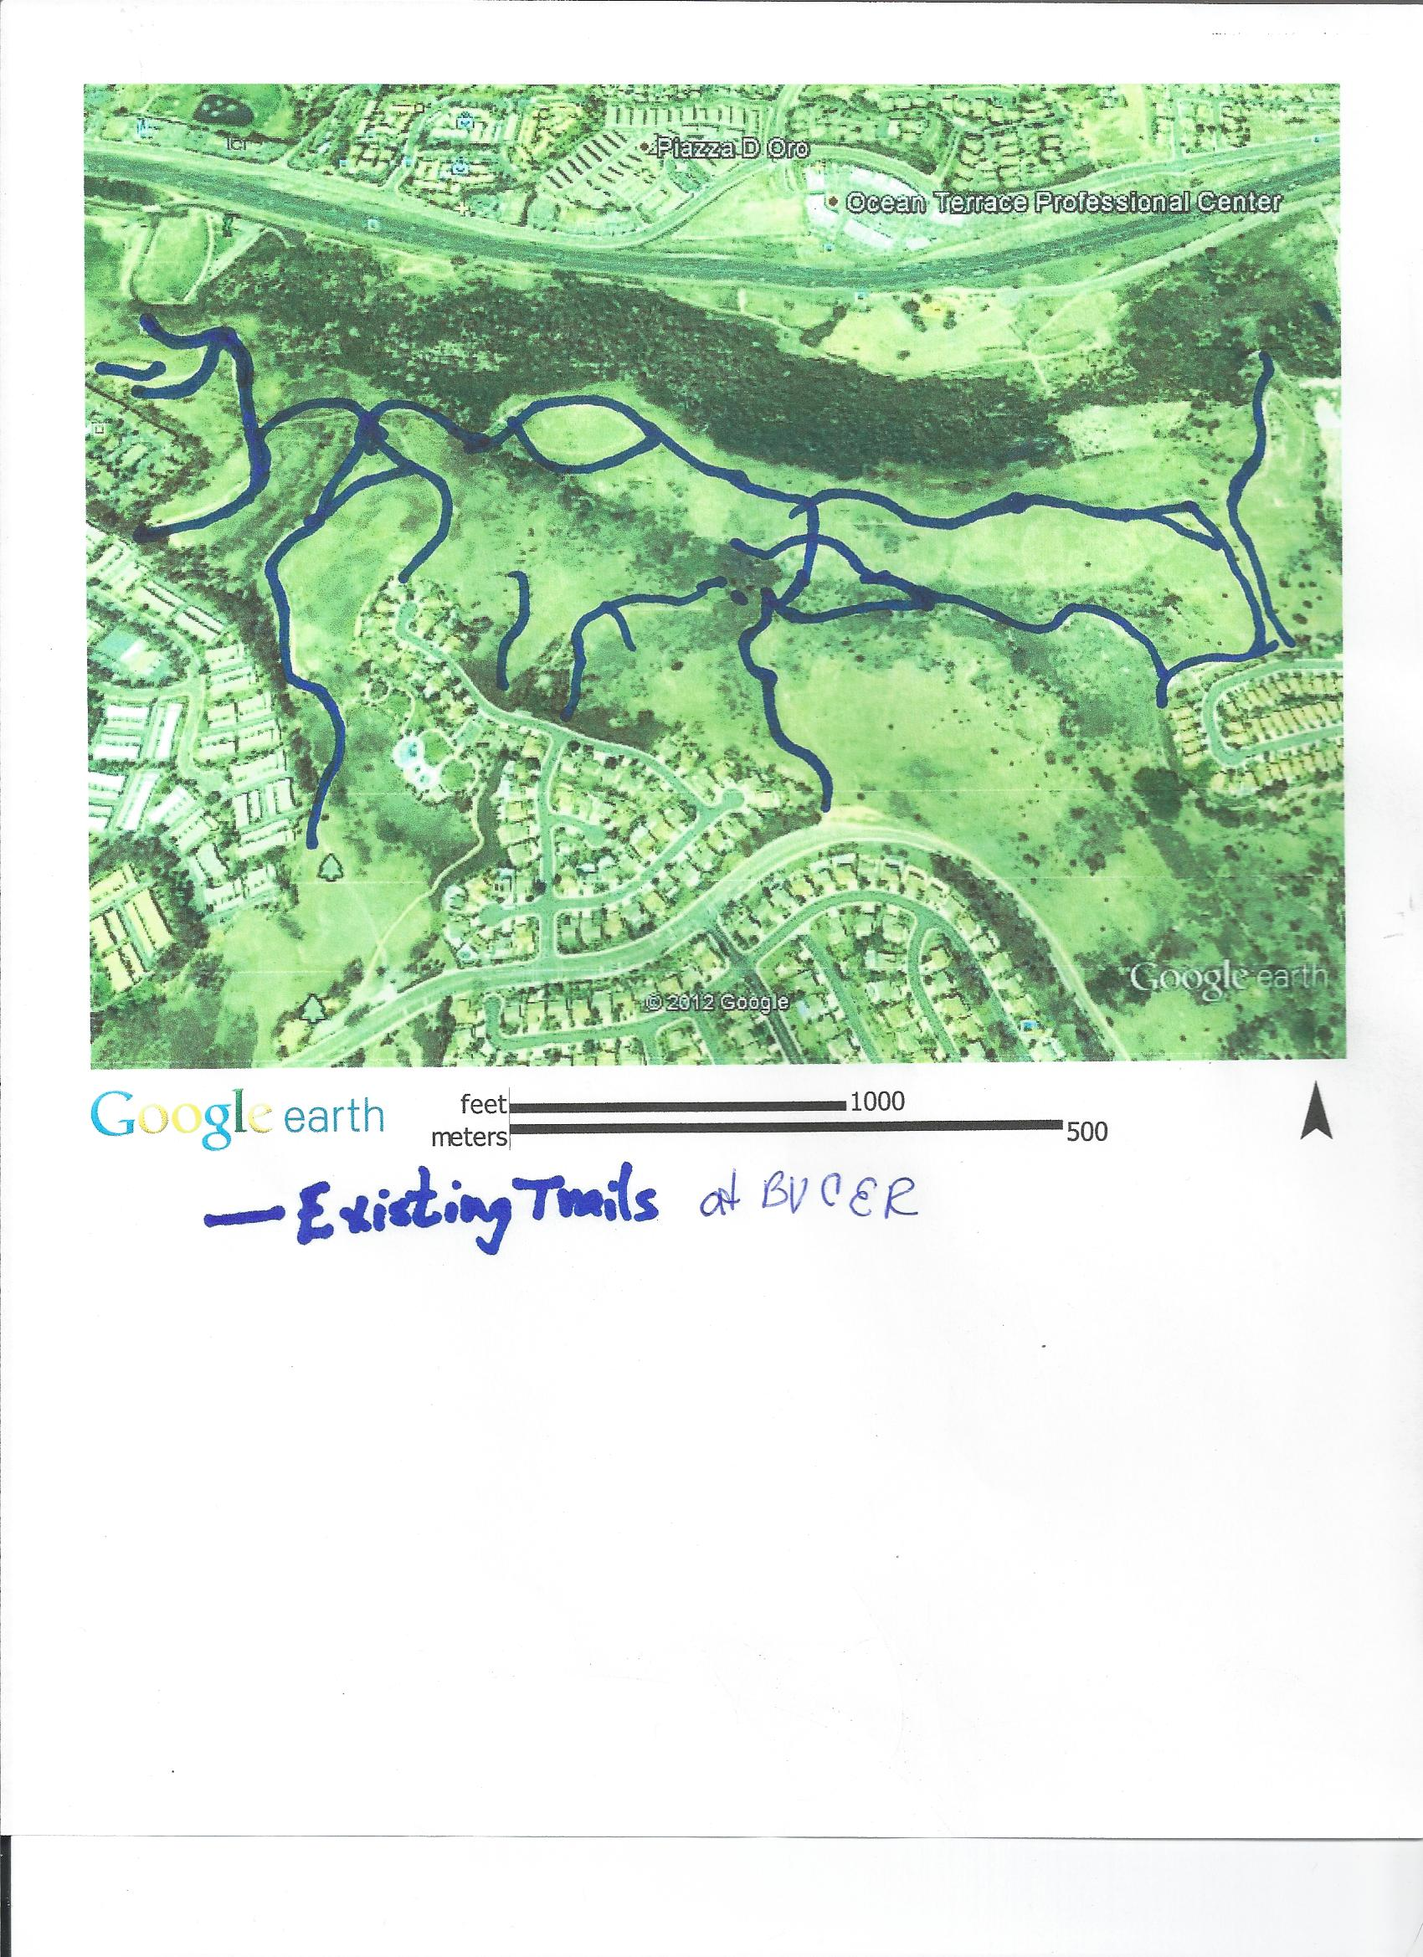

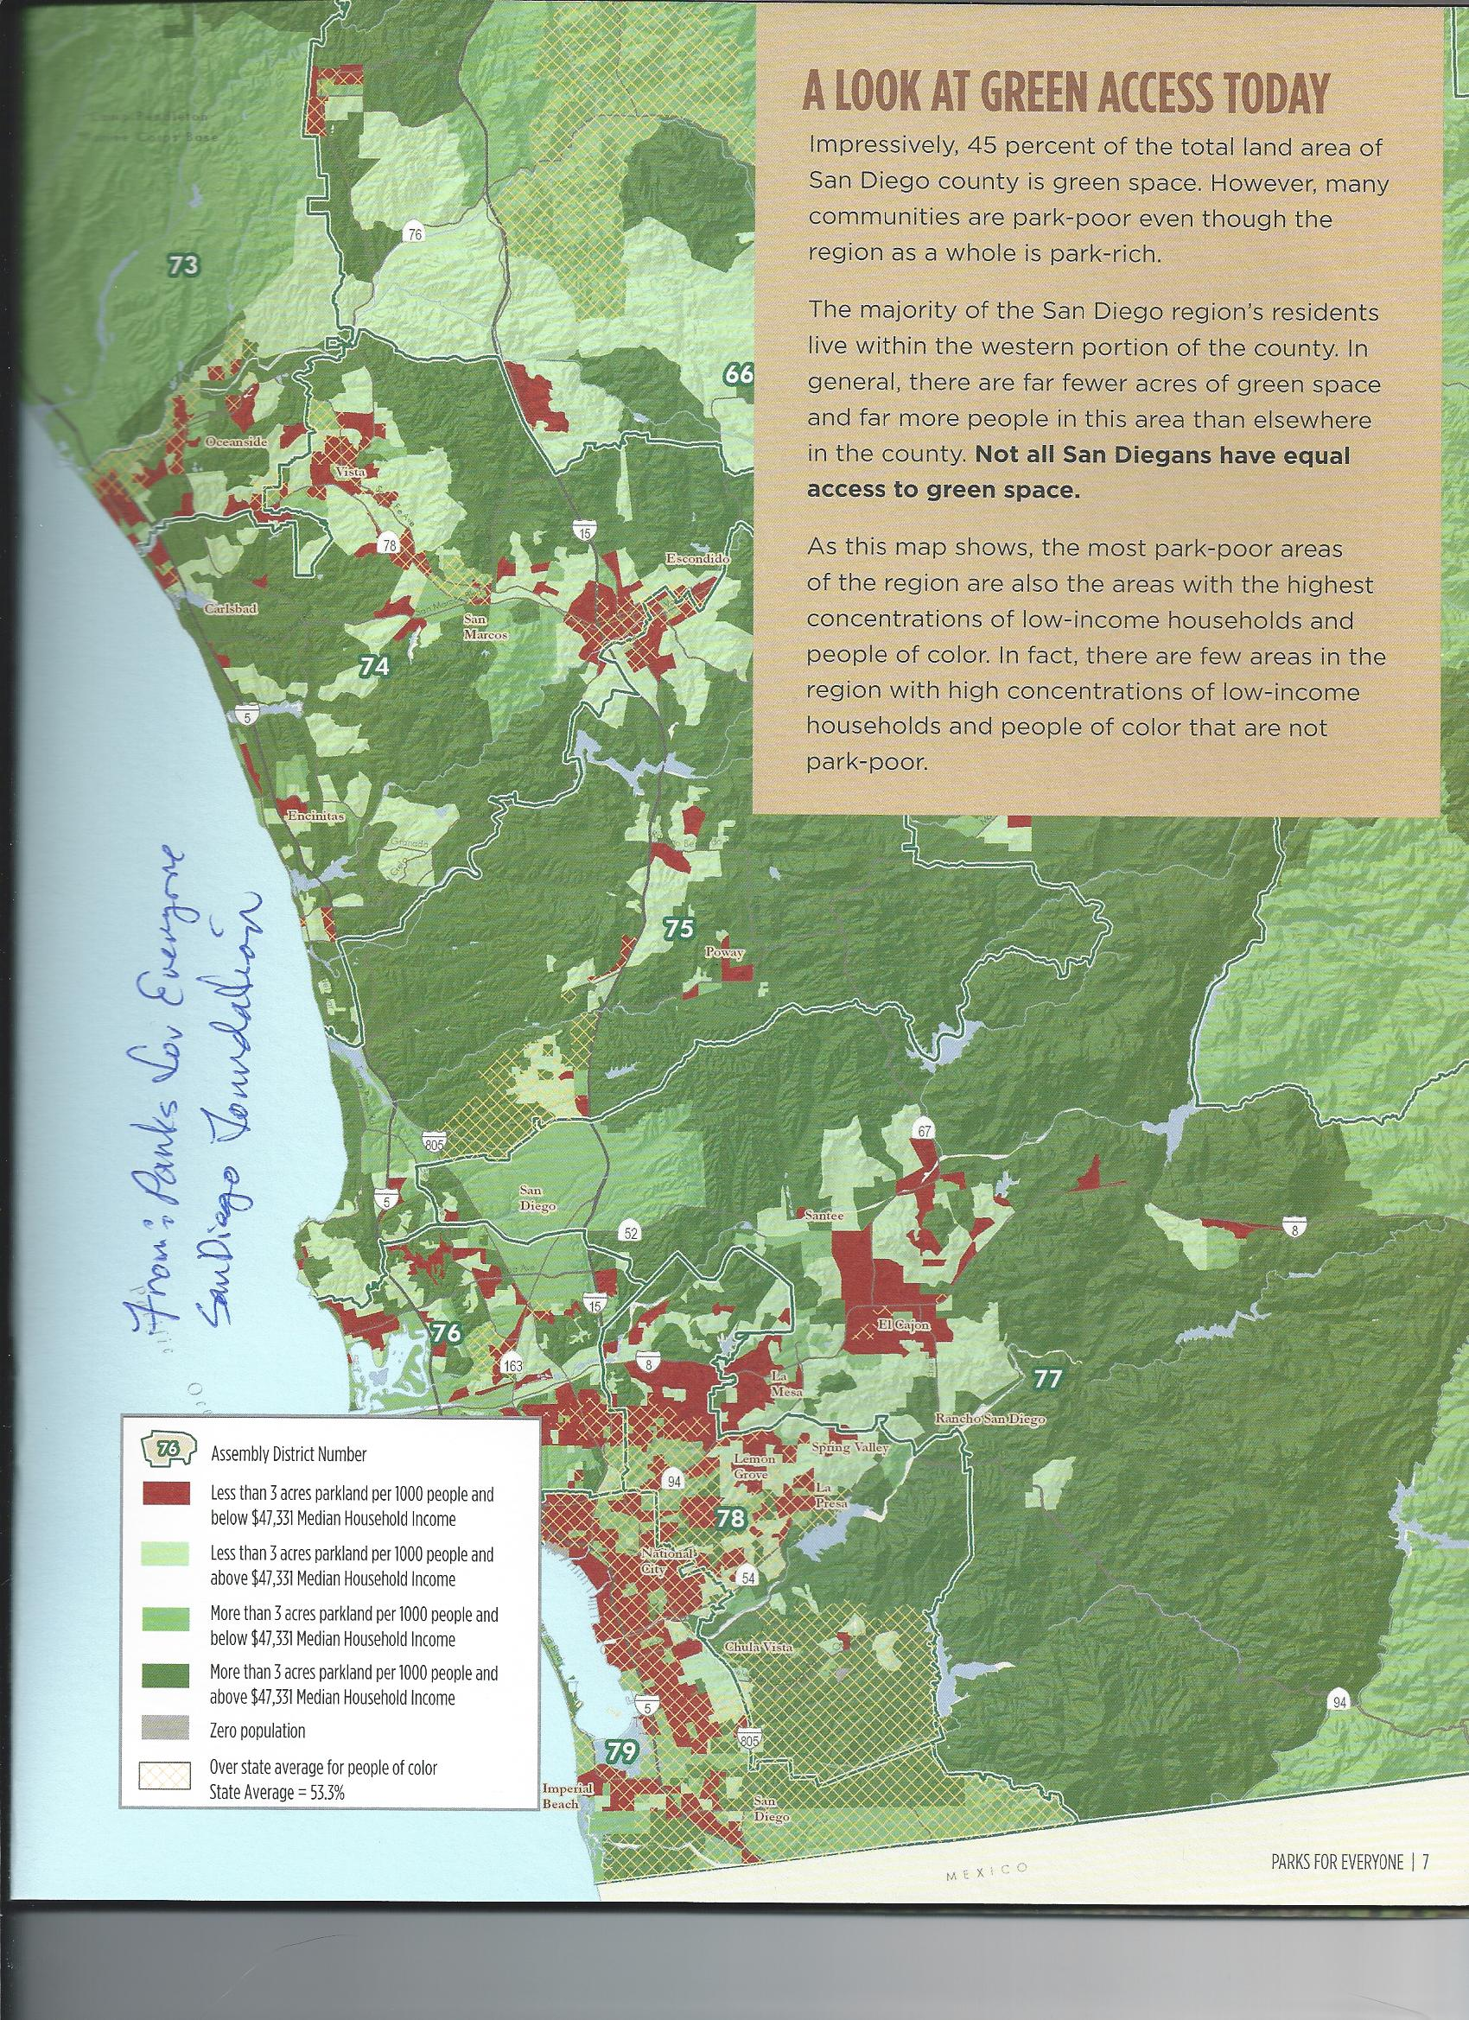

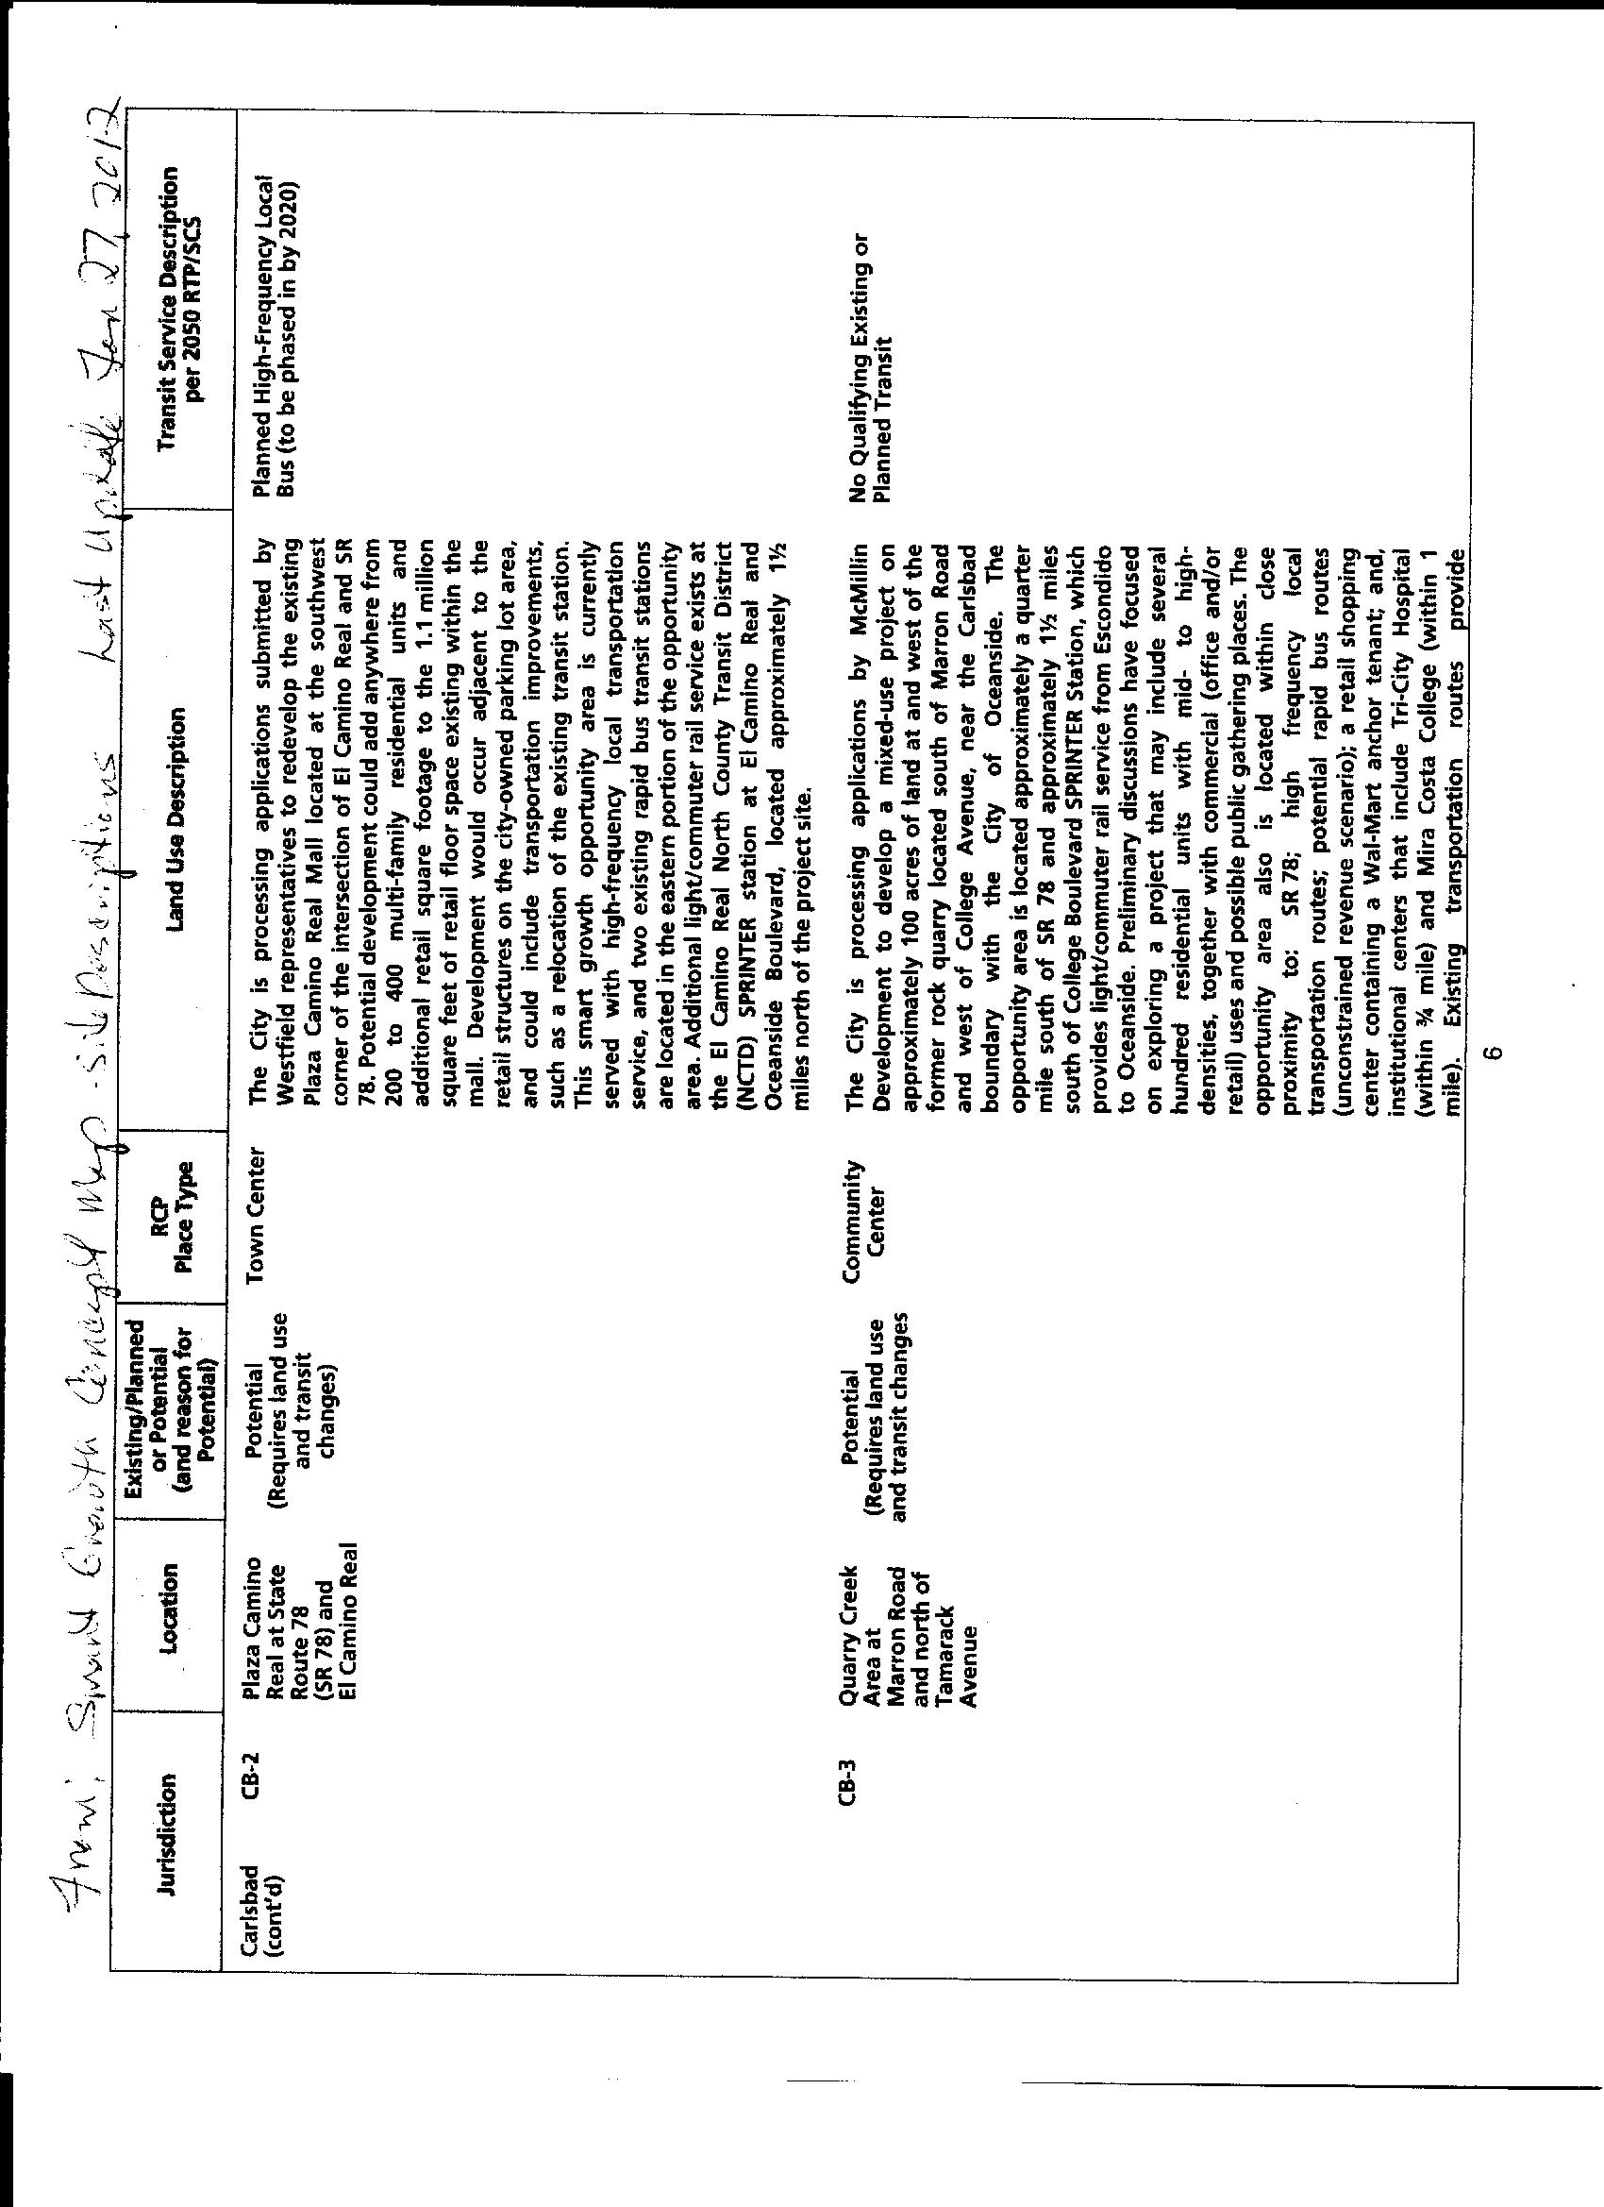

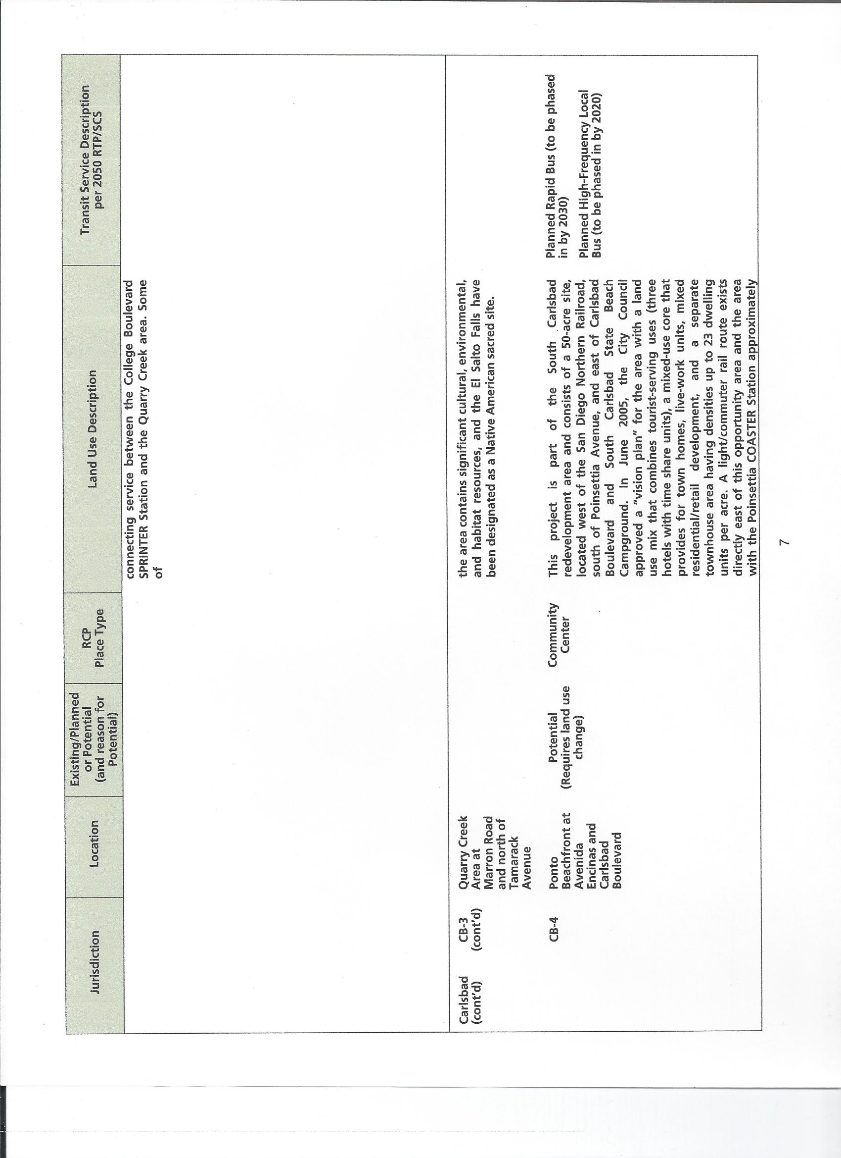
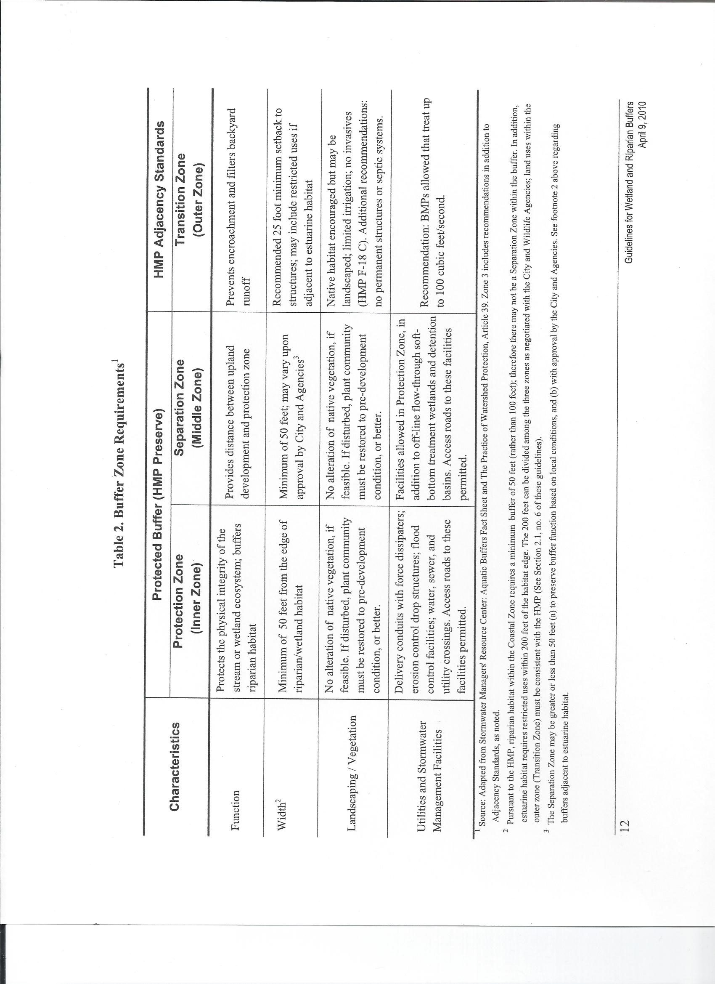
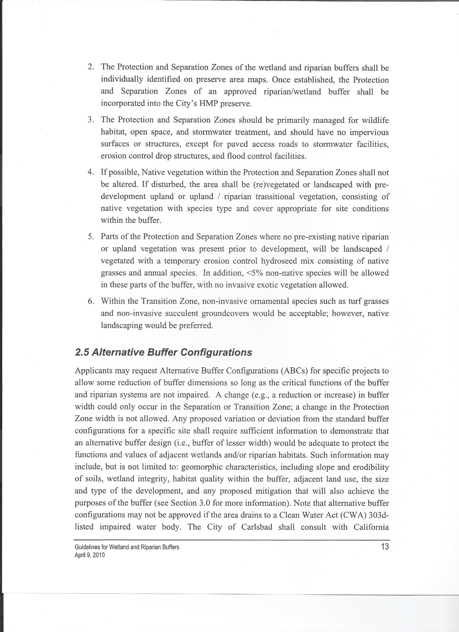

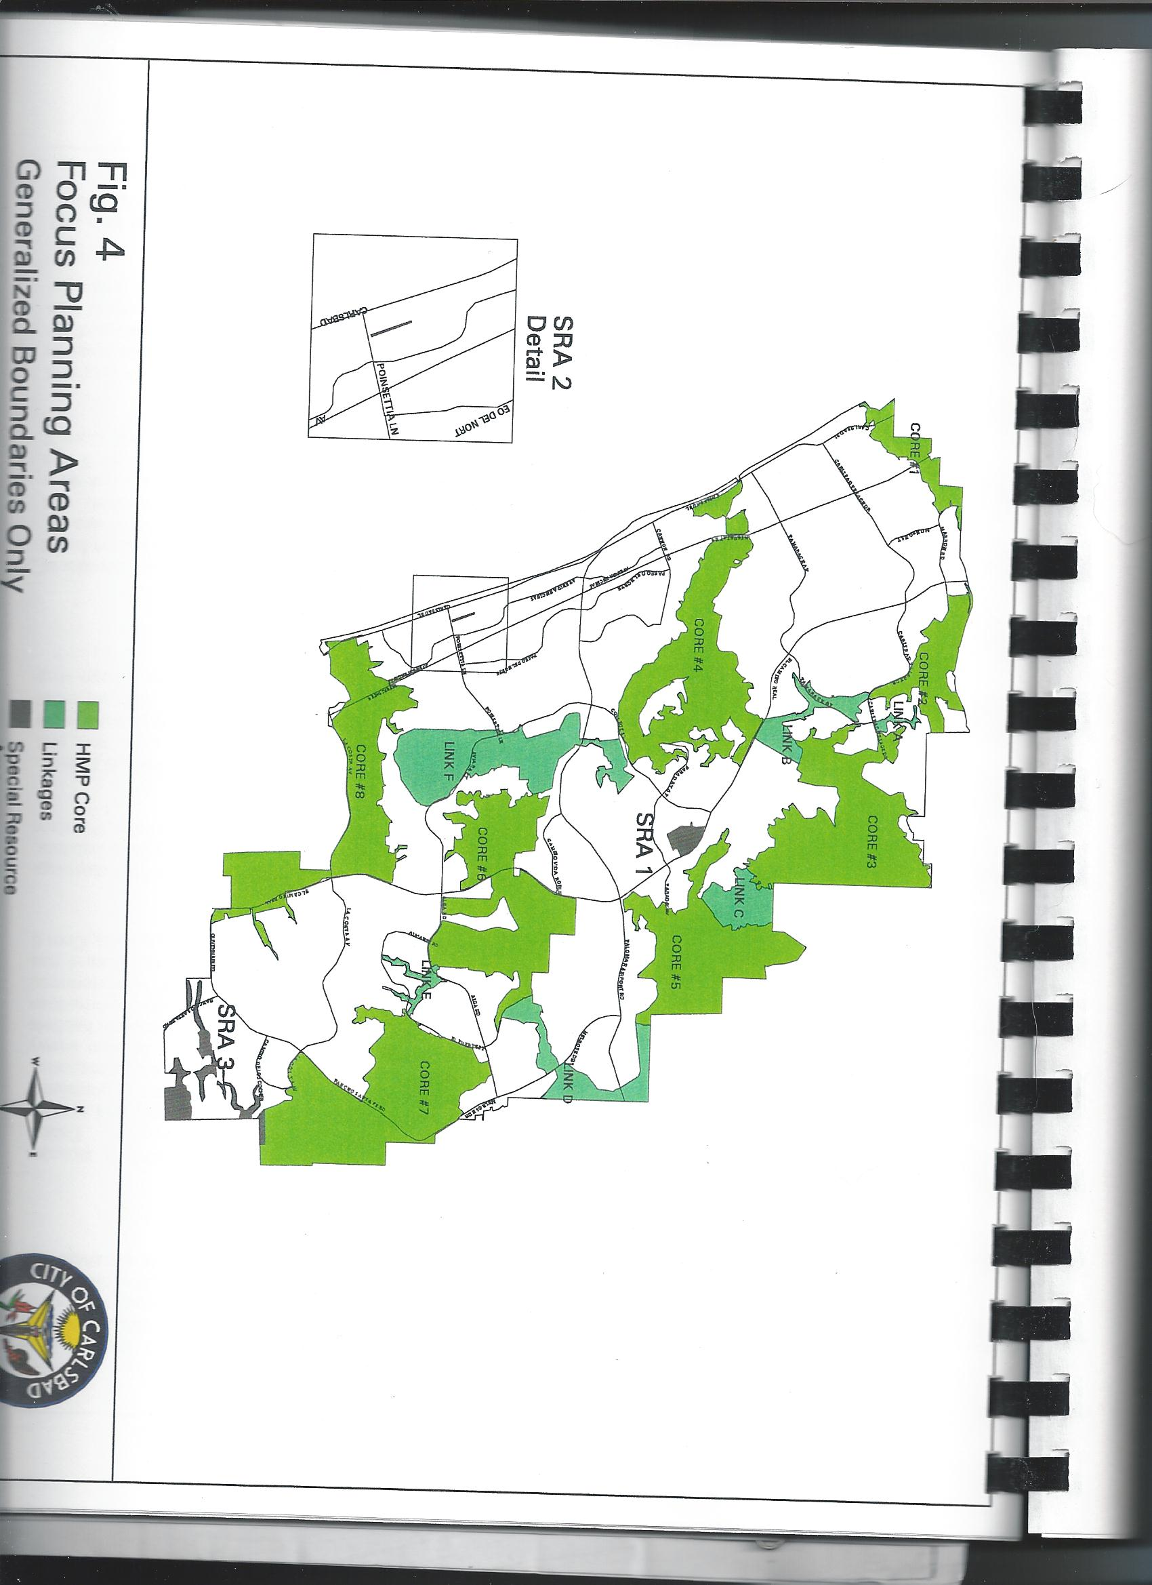
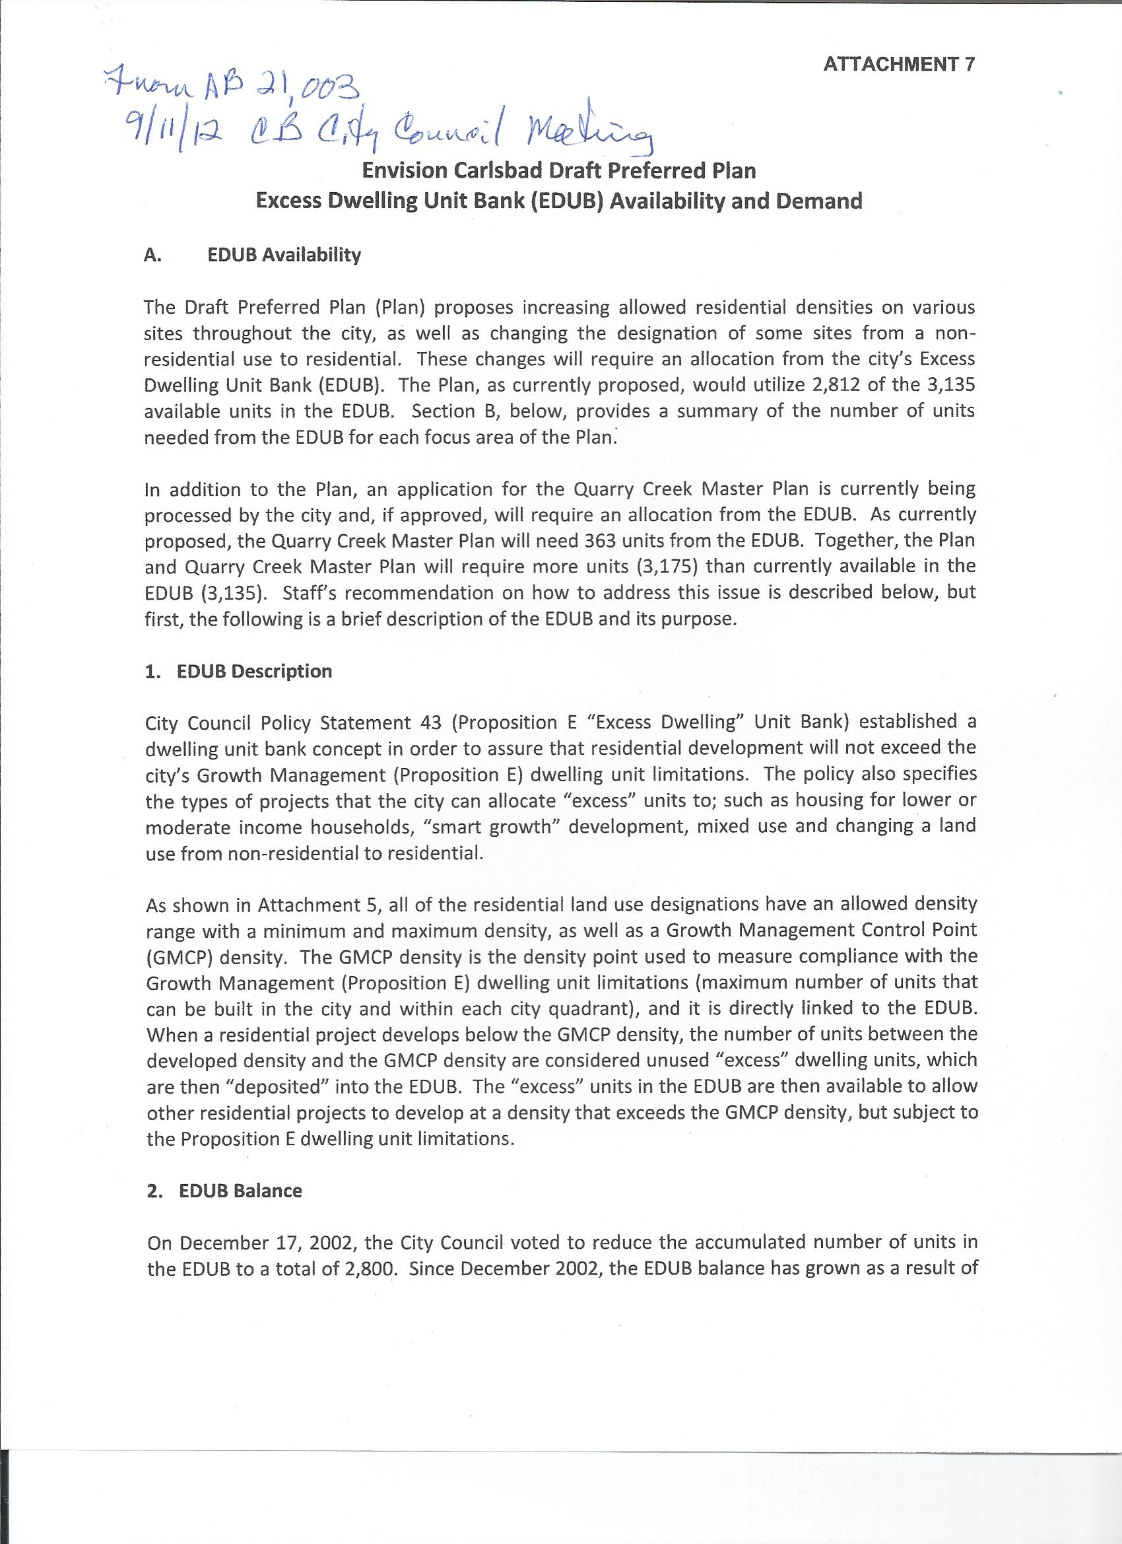

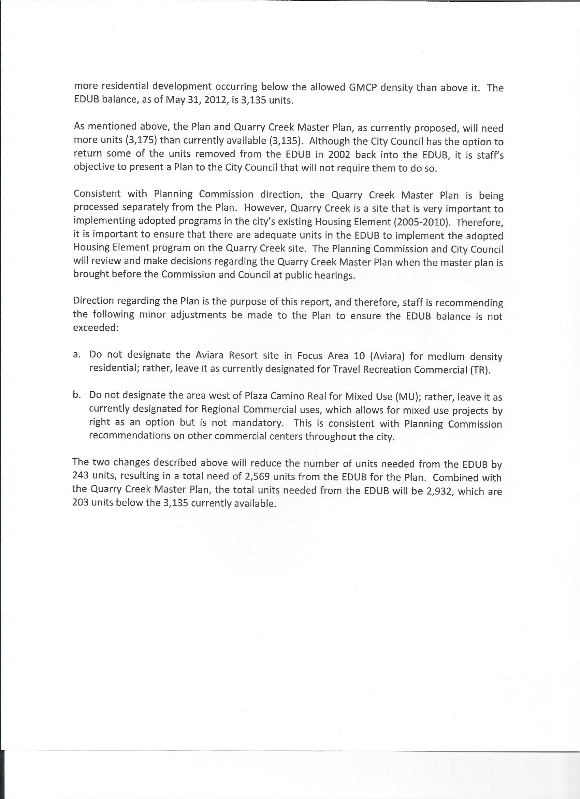

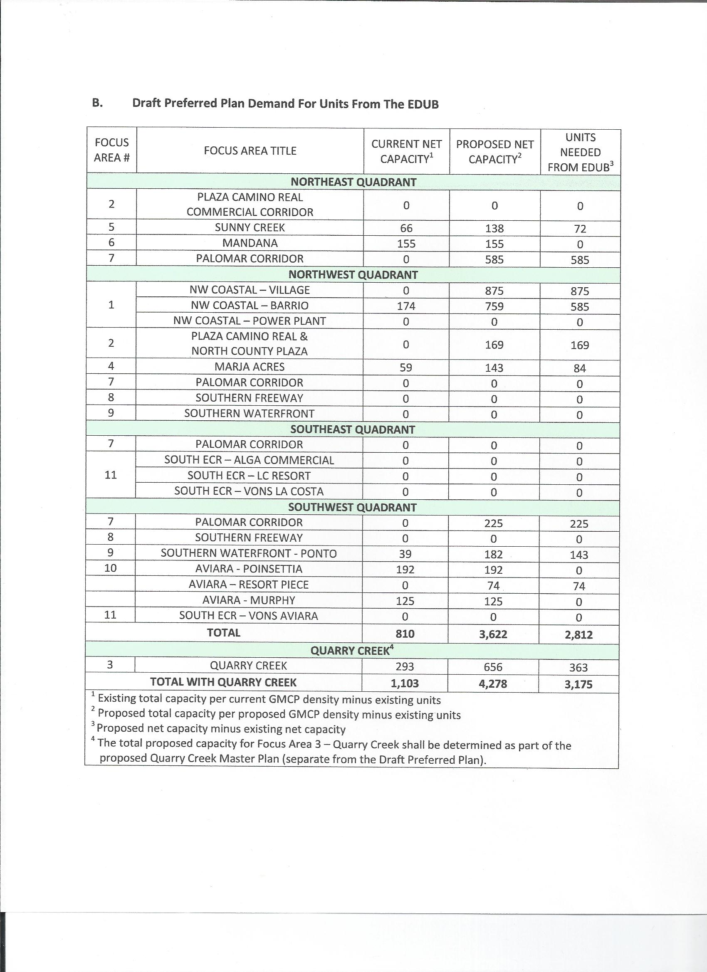
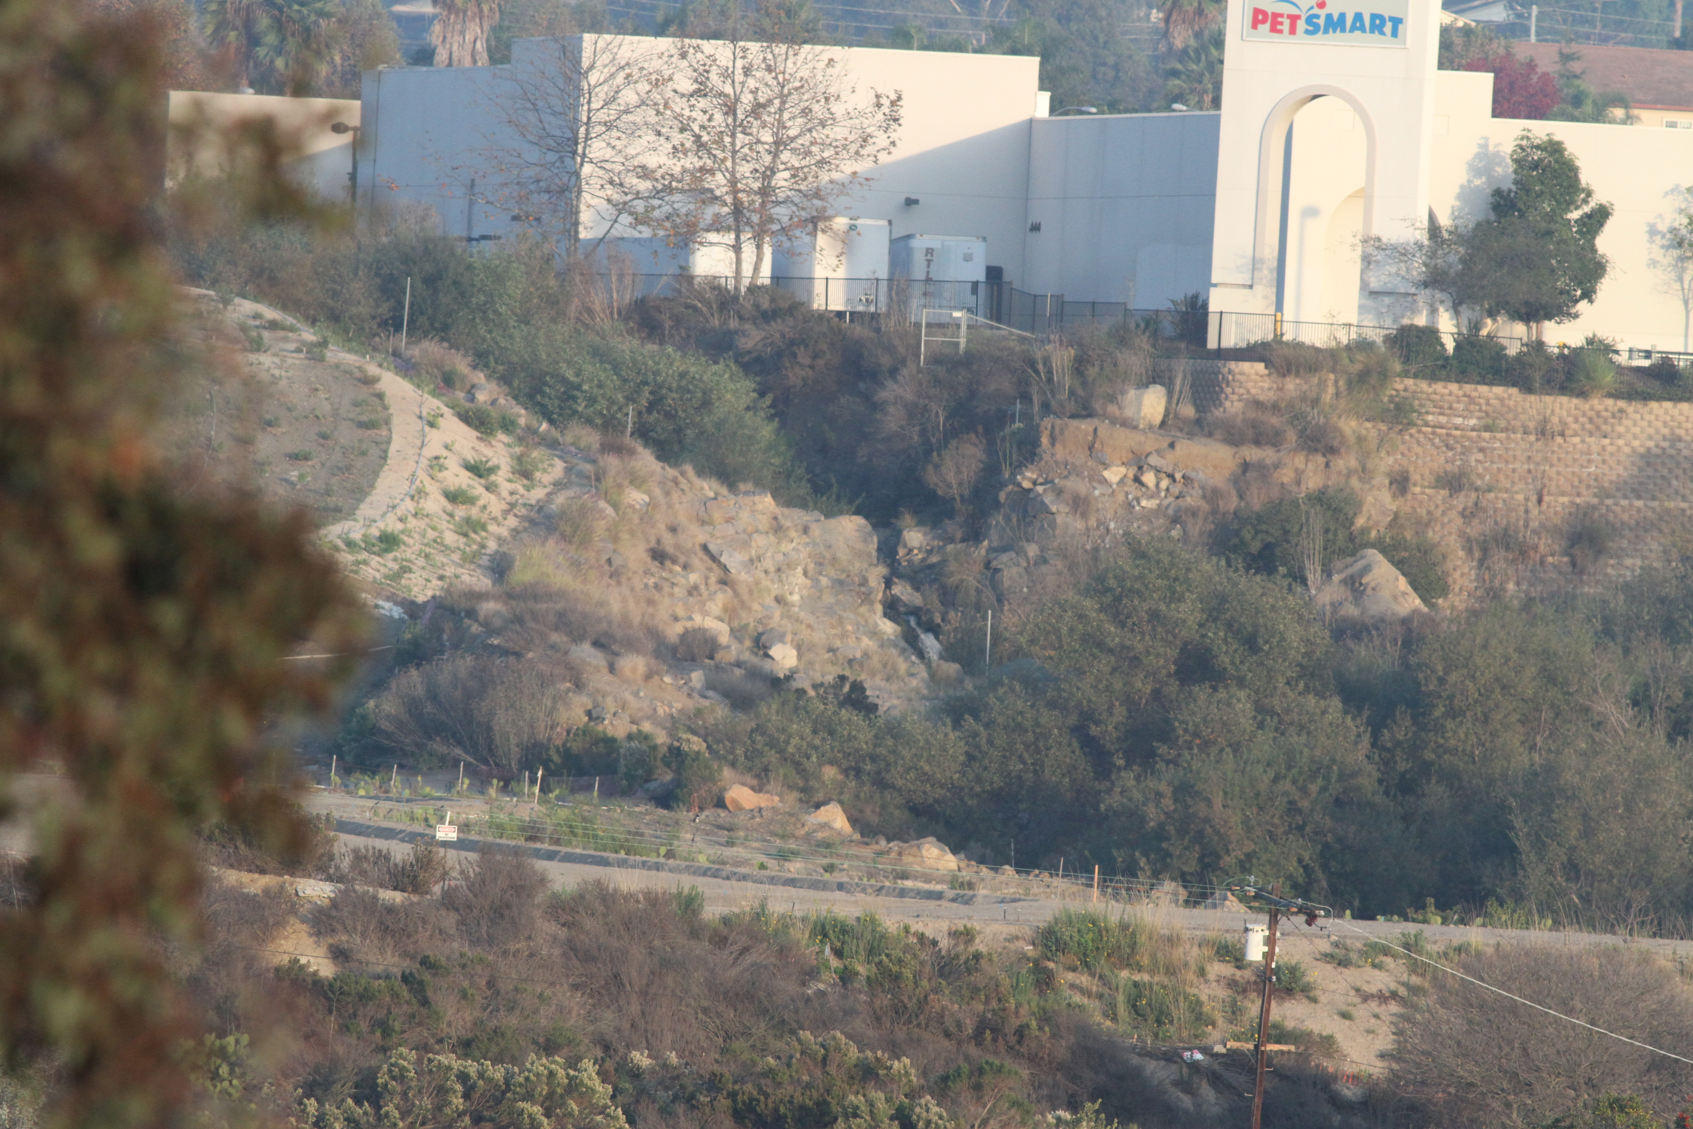
El Salto Falls Taken from Front Yard of Marron-Hayes Adobe Dec 5, 2012

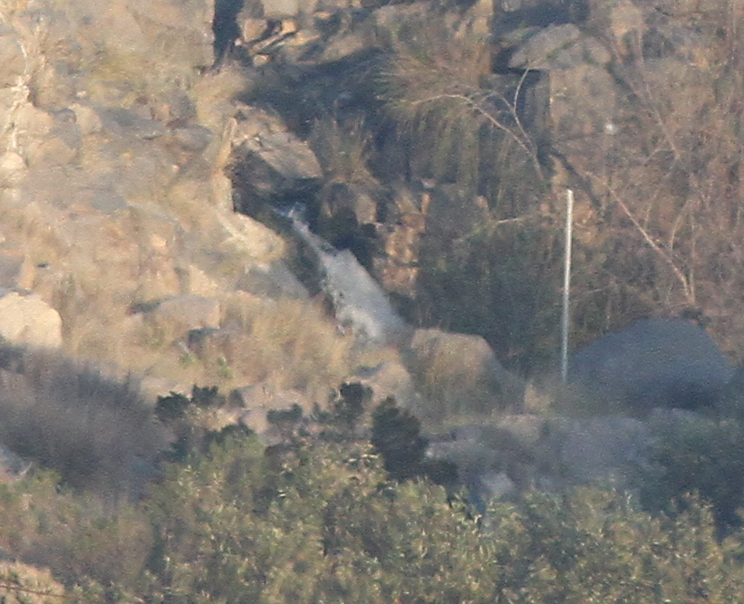

Close-up El Salto Falls Taken from Front Yard of Marron-Hayes Adobe Dec 5, 2012

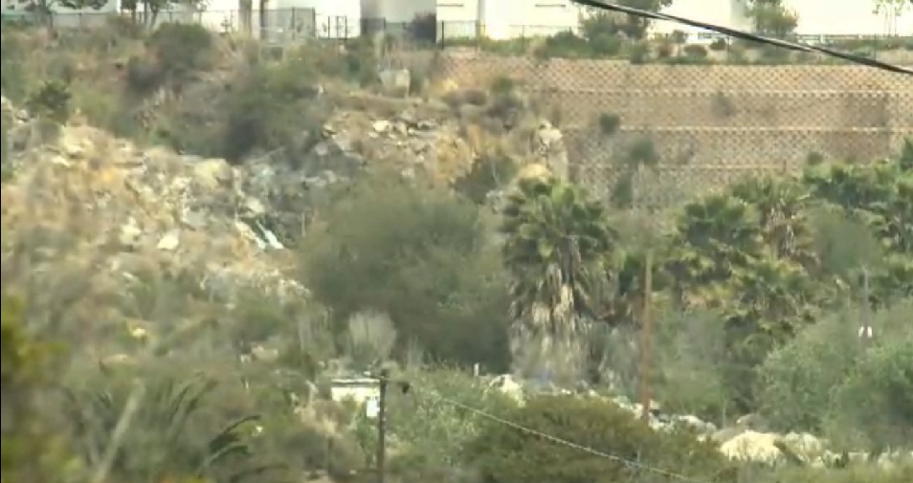

El Salto Falls Taken from Front Yard of Marron-Hayes Adobe May 22, 2009
From KPBS Documentary

Personnal communication Susan Baldwin and Diane Nygaard
Fischer, Richard A. and Fischenich, J. Craig, Design Recommendations for Riparian Corridors and Vegetated Buffer Strips, EMLLP, April 2000, p.2
IBID, p3.
IBID p. 11.
IBID p.13.
Paul Beier, Dan Majka, Shawn Newell, and Emily Garding; Best Management Practices for Wildlife Corridors, Northern Arizona University, January 2008, p2.
Principles of Wildlife Corridor Design, Minica Bond, Center for Biological Diversity, October 2003, p 2.
Domestic Cat Predation on Birds and Other Wildlife, see www.abcbirds.org/abcprograms/policy/cats/materials/predation.pdf
Crooks, p17.
See HMP Annual Reports and Preserve Manager Reports
MHCP Biological Goals, Standards and Guidelines, Ogden, 1998, p 6-2..
IBID p. 6-3.
IBID, p 6-3.
IBID , p 6-3.
IBID. P 6-5.
Personal Communication Sean Hogan and Diane Nygaard, November 8, 2012.
Final New High School at College and Cannon Environmental Impact Report, The Planning Center, December 2008, page D-31, Table 5.
Excess Dwelling Unit Bank Summary October 2012
City of Carlsbad 2010 Growth Management Report, p.2.
HMP, Special Terms and Conditions p.3.
Email November 19,2012 Van Lynch to Diane Nygaard.
City of Carlsbad Pending Planning Applications, December 2012.

