Quarry Creek - Save the Panhandle Fact Sheet
McMillin proposes to build 656 homes in the Buena Vista Creek Valley- a development they call Quarry Creek. It is located on the south side of # 78 between College and El Camino Real. The eastern 100 acres was mined for years and is currently undergoing reclamation. The western 56 acres, called the panhandle, was not mined, is part of the regional wildlife movement corridor, and is opposite the historic adobe.
Key Concerns :
- In 2008 the Carlsbad Citizen’s Committee ranked this the # 1 priority property to preserve in the entire city. It includes the sacred El Salto waterfall and regional wildlife corridor and is adjacent to the 134 acre Buena Vista Creek Ecological Reserve- an area we all worked so hard to acquire as permanent open space. If we don’t preserve the most important lands, what will we have left to preserve?

- Save Our Heritage Organization (SOHO) identified this area as one of the 12 most endangered historic sites in all of San Diego County. It includes Native American village sites dating back 9,000 years and the historic Marron Adobe and is a key focus of local history. Nowhere else has this unique combination of historic, cultural and natural resources. Homes can be built anywhere- but this area can’t be replicated.

- 100% of the project traffic will use College Blvd, causing traffic failures in Oceanside ( College, Lake, Plaza, Vista Way, # 78 ramps). Real traffic mitigation will require reducing the number of units, funding for expanded public transit service, and extensive bicycle/pedestrian trails.

- Current zoning allows a maximum of 293 housing units- less than half what this developer is proposing. Why does the developer get windfall profits through additional units and we get traffic congestion, noise, air pollution and lose our open space? There needs to be some balance.

- This is not “Smart growth” per SANDAG’s criteria. It is just dense development and more urban sprawl that is a step backwards from sound land use planning.

- The City of Carlsbad wants to put 506 affordable housing units here. They would all fit on the eastern part of the site- leaving the panhandle intact.
Recommendation:
Save the panhandle. Reduce/move development to the eastern part of the site and keep the panhandle as open space. Have developer subsidize public transit and provide bike/ped trails.
For more info go to www.preservecalavera.org or call 760-724-3887
Things You Can Do to Save the Quarry Creek Panhandle
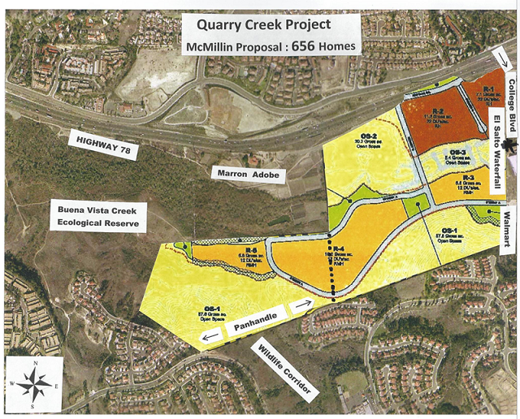
What Can YOU Do to Save This Priceless Valley ?
- Go to our website for more info and to see two videos www.preservecalavera.org

- Attend critical Planning Commission hearing When : 6 pm Wed Feb 20th
Where: Carlsbad City Hall, 1200 Carlsbad Village Dr

- Sign petition at http://www.gopetition.com/petitions/sos-for-open-space.html

- Call and email Mayor Matt Hall and Carlsbad Council members at council@carlsbadca.gov or 760-434-2808 and tell them why they should save the panhandle of Quarry Creek, to reduce the number of units below 656 because this traffic is not acceptable, require high frequency public transit through this area, and improve bicycle and pedestrian trails.

- Send a Letter to the Editor alerting the public about the potential loss of this area and why it is important to preserve the panhandle. Limit letter to 200 words, include your name, address and phone number (for verification- will not be printed). Send to both letters@utsandiego.com and letters@coastnewsgroup.com.

- Take everyone you know to the cul-de-sac on Haymar to see the valley, and to the sign-post behind Kohl’s to see the waterfall. Show them the treasure we have in our backyard. Attend one of our Mini- tours – 10-11 am on Sat Feb 23 or Mar 16th.

We Can Do This- we can save the panhandle from development and keep the heritage of this valley intact for us and for future generations- And with your help we will !

