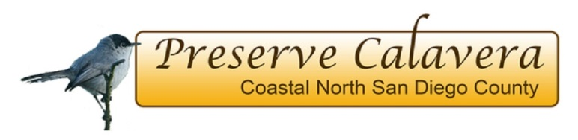

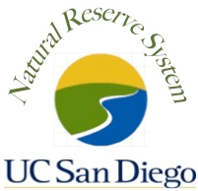
JANUARY 2017
UC CALIFORNIA NATURALIST
CERTIFICATION COURSE

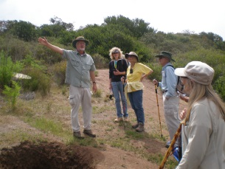
If you enjoy exploring and learning about our local ecology, engaging in citizen science and sharing your knowledge with others, this program is for you! The 40 hour course combines a science curriculum with guest lecturers, field trips and project-based learning to explore the unique ecology and natural history of coastal north San Diego County.
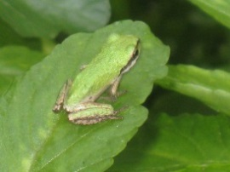
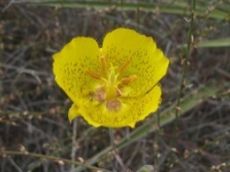
Evening (5:30-8:30 pm) classes will be held at the Buena Vista Nature Center in Oceanside on Tuesdays starting on Jan. 10, 2017 through March 14. Four or five Saturday field trips are planned at different preserves in our area. Each participant will complete a capstone project and present his/her results to the class.
This course is being offered by Preserve Calavera in collaboration with UCSD’s Natural Reserve System. The lead instructors are Paige DeCino, Karen Merrill, and Isabelle Kay.
Fee: Registration is $250. A limited number of need-based scholarships are available. Students must purchase The California Naturalist Handbook (2013, UC Press). Four UC academic credits are available at the completion of the class for $85. Registration is limited to the first 25 applicants.
To register go to www.preservecalavera.org. For more information about the course in general see: California Naturalist website.

